**C:\Users\ARGE - MUSTAFA\Desktop\mustafa\STANDARTLAR\CE\ŞENGÜN ESKİ CE\sengun stıker\logo.tif**

**MODEL**

**SEN 280-400   
MINI OVEN**

**(TOASTER OVEN)  
  
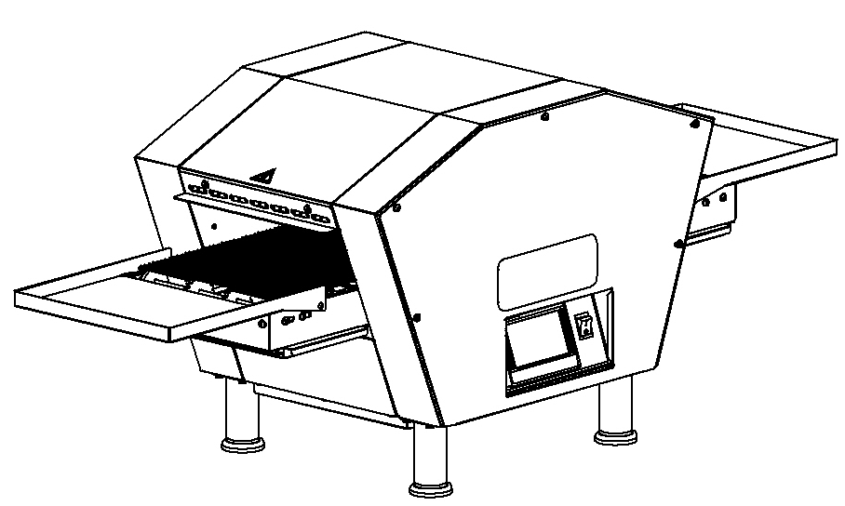**

**Z:\masaüstü\MAKİNALARIMIZ\FIRINLAR\SEN 2000 ÜFLEMELİ FIRIN (TEK BANT SERVO MOTOR)\SEN 2000\KATALOGLAR\Sen2000 Katalog\sen 2000 son çalışma\şerit2.png USER & MAINTENANCE MANUAL**

**ŞENGÜN MAKİNA İNŞAAT ve KIRTASİYE SAN. TİC. LTD. ŞTİ**

**This device must be installed in accordance with regulations. Refer to the instructions before installing and using the device.**

**These instructions apply only if the country code is shown on the device. If the country code does not appear on the device, refer to the technical instructions that give instructions for adapting the device to the country.**

**WARRANTY CERTIFICATE**

**SERIAL NUMBER** :

**SALE DATE** :

Sold at the above date SEN **– ……. MODEL MICROPROCESSOR CONTROL BLOWING OVEN** is guaranteed against production failures for **1** **Year** by **ŞENGÜN MAKİNA İNŞAAT ve KIRTASİYE SAN. TİC. LTD. ŞTİ**.

**Warranty Terms;**

- Warranty terms start after the product delivery for 1 year.

- Recommended daily working time is 10 hours. The scope of warranty is assessed by year or by working hours.  
- Documents are invalid, if haven’t sale date and confirm signature of company. You have to show the warranty certificate to benefit from the warranty.

- Device is guaranteed against defects if mount and use as described ın the use and maintenance manual.

- Detection the location of defects, and elimination of the problems are responsibilities of the **ŞENGUN MAKİNA**…

- Warranty terms includes only one device. You can’t claim any rights or compensation for another devices.

- If Changes are made at the type, model and serial numbers, the warranty eliminates.

- If material, worker or assembly defects appear, repaired free by **ŞENGÜN MAKİNA** at the product warranty period (Transportation cost is not included).

- Failures are only repaired by **ŞENGÜN MAKİNA’s** personal. The intervention of unauthorized person, cancel the appliance of warranty.

- Installation have to be done by **ŞENGÜN MAKİNA’s** personal. İf usage place changes, customer must give information to **ŞENGÜN MAKİNA**

- In the event of failure service must be informed.

- The failures and damages given by external factors are out of the warranty terms.

- Any failure of the product warranty period is added to the product warranty time. The repair time is until 20 working days.

- Istanbul courts are competent in case of dispute.

**AUTHORIZED PERSON**

**STAMP –SIGNATURE**

**PRESENTATION**

Dear Users,

Thank you for your prefer our machine and confidence in our company. Our machines are used in 39 countries.

Our machine is manufactured according to international standards. Please read the operating manual to get the mast out of your machine .Please note the following warnings before calling our service.

**ŞENGÜN MAKİNA**

* Please read the manual carefully before installing the machine.
* The machine will be out of warranty when your operate the machine with at read.
* Please read carefully the manual that gives you information on the installation is prepared in accordance with the legal regulations before arriving at the machine installation.
* For information you coo not understand, ask your nearest out horized service.
* Please note that if the technical service personnel is kept waiting you will be billed for each hour.

**IMPORTANT WARNINGS AND SAFETY INFORMATIONS**

** WARNING:** This manual contains important safety and installation-operation instructions. Require all operators to read this manual thoroughly before installing, operating or servicing this equipment. Improper installation, adjustment, alteration, service or maintenance can cause property damage, injury or death.

** WARNING:** This appliance is not intended for use by young children or infirm persons unless they have been adequately supervised by a responsible person to ensure that they can use the appliance safely. Young children should be supervised to ensure that they do not play with the appliance.

** WARNING:** Improper installation, adjustment, alteration, service or maintenance can cause property damage, injury or death. Read the installation, operating and maintenance instructions thoroughly before installing or servicing this equipment.

** WARNING!** Do not work around conveyor belt with long hair, loose clothing, or dangling jewelry. Getting caught in the belt could result in serious injury.

** WARNING!** For your safety, do not store or use gasoline or other flammable vapors or liquids in the vicinity of this or any other appliance.

** WARNING!** If the power supply cord damaged, do not attempt to operate the unit. Contact a service agent or qualified electrician to repair!

** WARNING!** Do not use paper when placing food product through the oven! Usage of flammable materials may cause a fire and should never be placed in the oven.

** WARNING!** Do not put any object to anywhere of the oven except the conveyor.

** WARNING!** Always be careful while you are working.

* The oven must be placed under a ventilator to provide for adequate air supply.
* Minimum clearances must be provided from all walls and combustible materials. Look “spacing requirements” section for more information.
* Always keep the oven clean and clear combustible materials.
* Keep adequate clearance for air openings.
* Do not obstruct the ventilation holes.
* The oven is to be operated only on as shown on the specification plate.
* This manual should be retained for future reference.
* Prepare a list of what you should do when you smell gas and keep it near the oven.
* Gas does not pass through the burner without electricity.

**Responsibilities of the Purchaser Company**

Responsibilities of the purchaser company are written at bottom;

* To see that the electric and gas services for the oven are installed in accordance with the manufacturers specification.
* İnstalling the oven and placing it as suggested at the catalogue.
* To see that the electric services are connected properly by a qualified installer of your choice.

WARNING

**Cleaning and maintenance are the most important factors of oven performance. The processes which are not available in the manual can cancel the appliance of warranty, cause property damage, injury or death. Read and understand the instructions in the manual**

WARNING

**Cleaning and maintenance are the most important factors of oven performance. The processes which are not available in the manual can cancel the appliance of warranty, cause property damage, injury or death. Read and understand the instructions in the manual**

**CONTENTS**

**WARRANTY CERTIFICATE**

**PRESENTATION**

**SECTION 1: INTRODUCTION**

**1.1** Introduction of Body Components

**1.2** Functions of Parts  
**1.2.1** Oven Body

**1.3** Microprocessor Control

**1.4** Cooking Function

**1.5** Conveyor (Belt)

**1.6** General Information

**1.7** Oven Specifications

**1.8** Electrical and Technical Specifications Table

**1.9** Dimensions

**SECTION 2: ASSEMBLE**

**2.1** Sheet Assemble

**2.2** Wire Belt Assemble

**SECTION 3: INSTRUCTIONS FOR USE**

**3.1** Distance Requirements

**3.2** Installation Elements

**3.3** SEN 280-400 MINI Oven Technical Specifications Table

**SECTION 4: PROGRAMMING-START & STOP**

**4.1** Utility Programs

**4.2** Manual Operation

**4.3** Cleaning Program

**4.4** Standby Mode

**4.5** Warnings

**4.6** Shutdown

**4.7** Error / Warnings Messages

**4.7.1** Temperature Determine Failure

**4.7.2** Temperature does not Rise

**4.7.3** Belt Engine Failure

**4.7.4** Temperature Limit Exceeded

**4.7.5** Low Battery Warning

**4.7.6** Ready

**4.8** Functions

**4.1.1** Temperature Switch

**4.8.2** Electrical Installations

**4.8.3** Operator Maintenance

**4.8.4** Cleaning Instructions

**4.8.5** Protective Maintenance

**SECTION 5: COOKED PRODUCTS**

**5.1** Some of the Cooked Products

**5.3** Total Cooking Calculation

**SECTION 6: SPARE PARTS MANUAL**

**SECTION 7: ELECTRICAL DIAGRAM**

**SECTION 8: TROUBLESHOOTING**

**8.1** Temperature Limit Exceeded

**8.2** Low Battery Warning

**8.3** Belt Engine Failure

**8.4** Temperature Determine Failure

**8.5** Temperature does not Rise

**8.6** Products do not Cooked

**8.7** Contact with Technical Services

**SECTION 9: LABELS**

**NOTE**

**SECTION 1: INTRODUCTION**

**1.1 Introduction of Body Components**

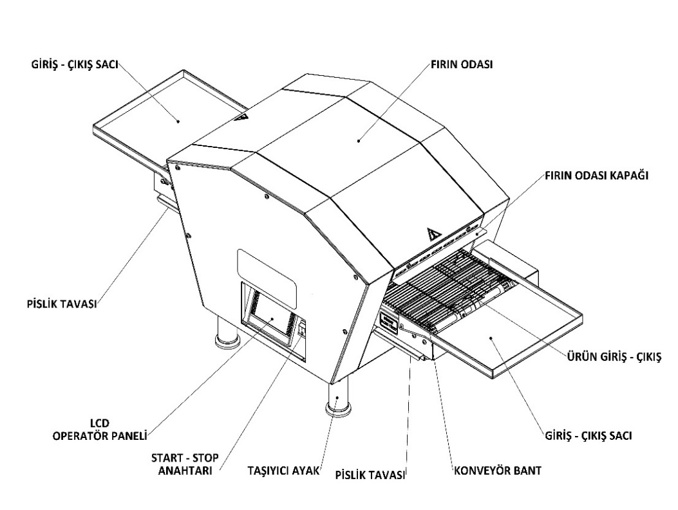

PRODUCT ENTRANCE/ EXIT SHEET

OVEN CHAMBER

ENTRANCE/EXIT COVER

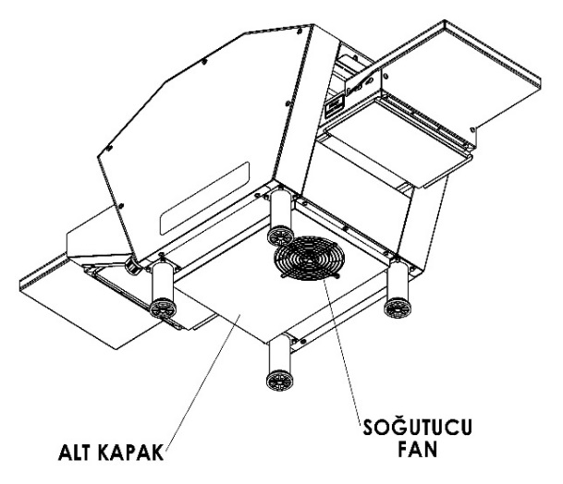

WASTE PAN

PRODUCT ENTRANCE/ EXIT SHEET

LCD CONTROL SCREEN

CONVEYOR BELT

ENTRANCE/ EXIT SHEET

LEG

WASTE PAN

ON/OFF SWITCH

COOLER FAN

BOTTOM COVER

***Note:*** *Entrance of product depends for the cooking style. The out sheet can be attached other side of the oven.*

**1.2 Functions of Parts**

**1.2.1 Oven Body**

Every SEN series oven has a main body.

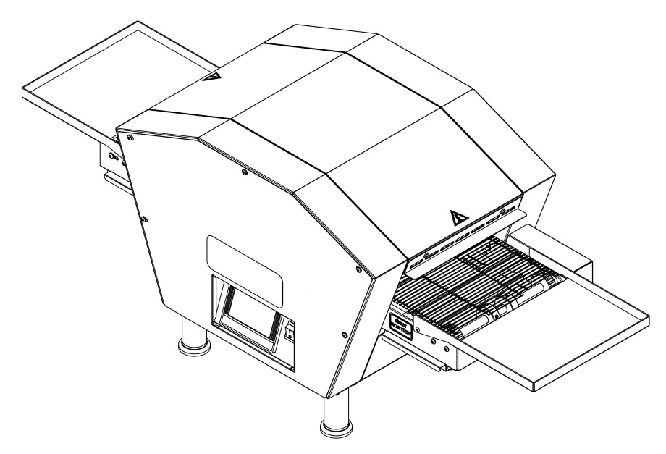

**1.3 Microprocessor Control:**

Every mini oven is controlled by separate programmable microprocessor. The microprocessor controls all functions of the oven. The upper heating zone can be set to the desired degree from 100°C to 600°C and the lower heating zone from 100°C to 500°C. And the cooking time can be set between 15 seconds to 5 minutes. Standby Mode provides energy saving. Also service module helps to the technicians. You can cook standard and delicious products in a short time.

**1.4 Cooking Function:**

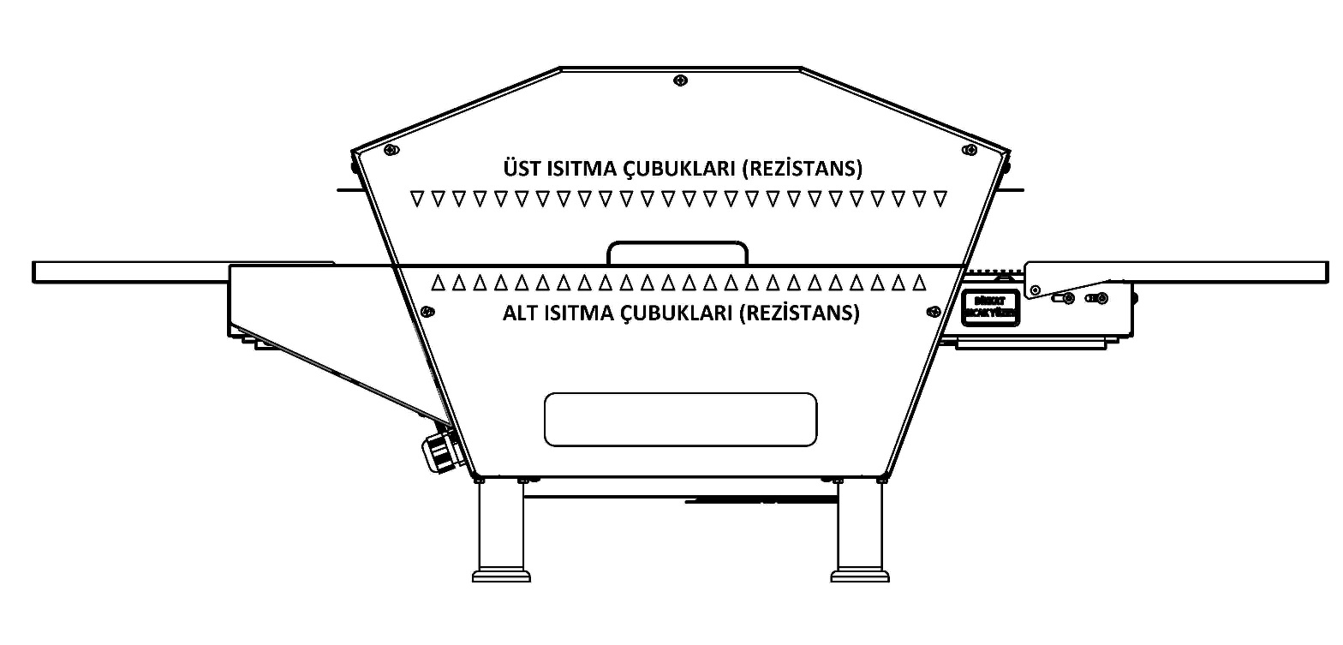Heat bars are placed top or bottom of the band. That bars send infrared heat waves. That waves don’t heat the air. They heat only upside of product. You can cook standard and delicious products in a short time.

TOP HEATER BARS (REZISTANCE)

BOTTOM HEATER BARS (REZISTANCE)

**1.5 Conveyor (Belt):**

Conveyors provide the input and output of the product. Belt is controlled by microprocessor. Cooking time can be set between 15 seconds to 5 minutes. The speed of belt determines the Products cooking time. The width of SEN 280 MINI belt is 278 mm, SEN 400 MINI belt width is 405 mm and consist by interlocking wires.

**1.6 General Information:**

* Information which are located at the following pages will guide you at installation of the oven.
* First of all check the parts of oven carefully.
* Before the installation determine a safety place for oven.

.  
**1.7 Oven Specifications:**

**SEN 280 MINI**

|  |  |
| --- | --- |
|  | **SEN 280 MİNİ** |
| Conveyor Belt Width **:** | 254 mm. |
| Heating Chamber Length **:** | 603 mm. |
| Heating Chamber Size **:** | L 603 mm. X W 278 mm x H 76mm. |
| Conveyor Cooking Area **:** | 0,17 m² |
| Overall Dimensions for Single Oven  **:** | Oven Width: 440 mm.  Oven Height: 490 mm.  Total Long: 1240 mm. |
| Weight **:** | 45 kg. |
| Transportation Weight **:** | 52 kg. |
| Transportation Size **:** | L 930 mm x W 500 mm x H 705 mm. |
| Average Usage kW **:** | 2,3 kW |
| Allowable Temperature Range : **:** | upper 100 °C – 600 °C, lower 100°C- 500°C |
| Conveyor Drive System **:** | 208 - 300 Volt Microprocessor  Conveyor control system. |
| Cooking Time **:** | 15 sec. – 5 min. Adjustable |
| Insulation **:** | 3 Side (Top/Right/Left) |
| Heat Source **:** | 18 Heat source |
| Oven Chamber **:** | 430 Stainless Steel |
| Steel Enclosure **:** | 430 Stainless Steel |
| DB Level **:** | < 30 dba |
| Source **:** | Electricity |

**1.8 Electrical and Technical Specifications Table:**

**Electrical and Technical Specifications Table**

|  |  |  |  |  |  |  |  |  |
| --- | --- | --- | --- | --- | --- | --- | --- | --- |
| **Voltage** | **Faze** | **N** | **T (PE)** | **Cable Minimum Section** | **kW** | **Ampere Load** | | |
| **L1** | **L2** | **L3** |
| **400V 50/60HZ** | **3** | **1** | **1** | **2,5 mm²** | **4,7 kW** | **7** | **7** | **7** |

***Note:*** *Specifications can be changed by Şengün Makina. Above Specifications are given for information.*

**SEN 400 MİNİ**

|  |  |
| --- | --- |
|  | **SEN 400 MİNİ** |
| Conveyor Belt Width **:** | 381 mm. |
| Heating Chamber Length **:** | 736 mm. |
| Heating Chamber Size **:** | L 736 mm. X W 405 mm x H 96mm. |
| Conveyor Cooking Area **:** | 0,30 m² |
| Overall Dimensions for Single Oven  **:** | Oven Width: 590 mm.  Oven Height: 530 mm.  Total Long : 1560 mm. |
| Weight **:** | 63 kg. |
| Transportation Weight **:** | 67 kg. |
| Transportation Size **:** | L 1660 mm x W 690 mm x H 630 mm. |
| Average Usage kW **:** | 4,1 kW |
| Allowable Temperature Range : **:** | upper 100 °C – 600°C, lower 100°C- 500°C |
| Conveyor Drive System **:** | 208 - 300 Volt Microprocessor  Conveyor control system. |
| Cooking Time **:** | 15 sec. – 5 min. Adjustable |
| Insulation **:** | 3 Side (Top/Right/Left) |
| Heat Source **:** | 24 Heat source |
| Oven Chamber **:** | 430 Stainless Steel |
| Steel Enclosure **:** | 430 Stainless Steel |
| DB Level **:** | < 30 dba |
| Source **:** | Electricity |

**Electrical and Technical Specifications Table**

|  |  |  |  |  |  |  |  |  |
| --- | --- | --- | --- | --- | --- | --- | --- | --- |
| **Voltage** | **Faze** | **N** | **T (PE)** | **Cable Minimum Section** | **kW** | **Ampere Load** | | |
| **L1** | **L2** | **L3** |
| **400V 50/60HZ** | **3** | **1** | **1** | **2,5 mm²** | **8,3 kW** | **12** | **12** | **12** |

***Note:*** *Specifications can be changed by Şengün Makina. Above Specifications are given for information.*

**1.9 Dimensions:**

**SEN 280 MINI**

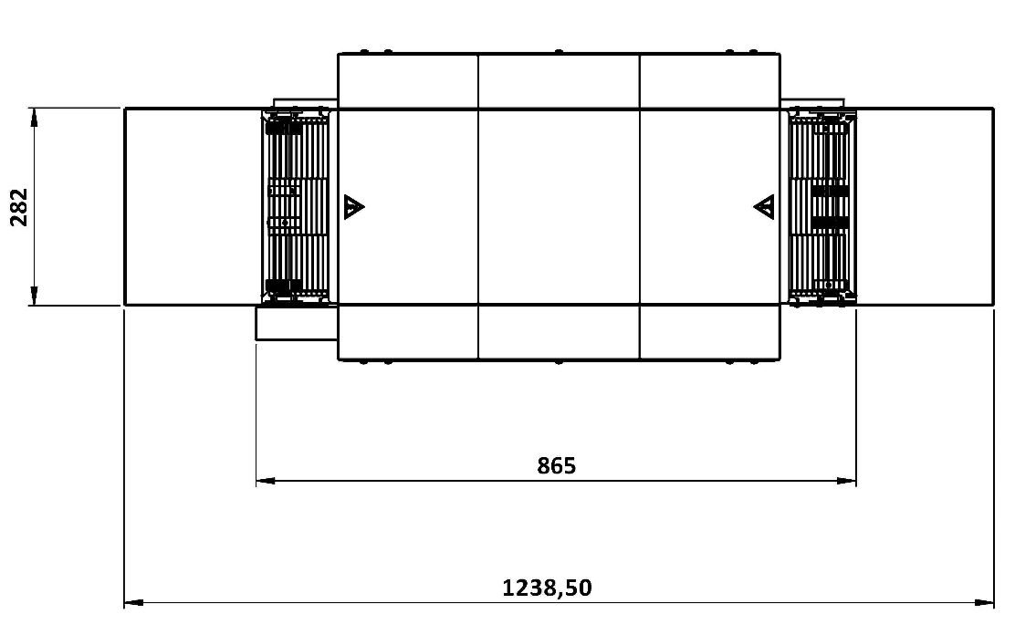

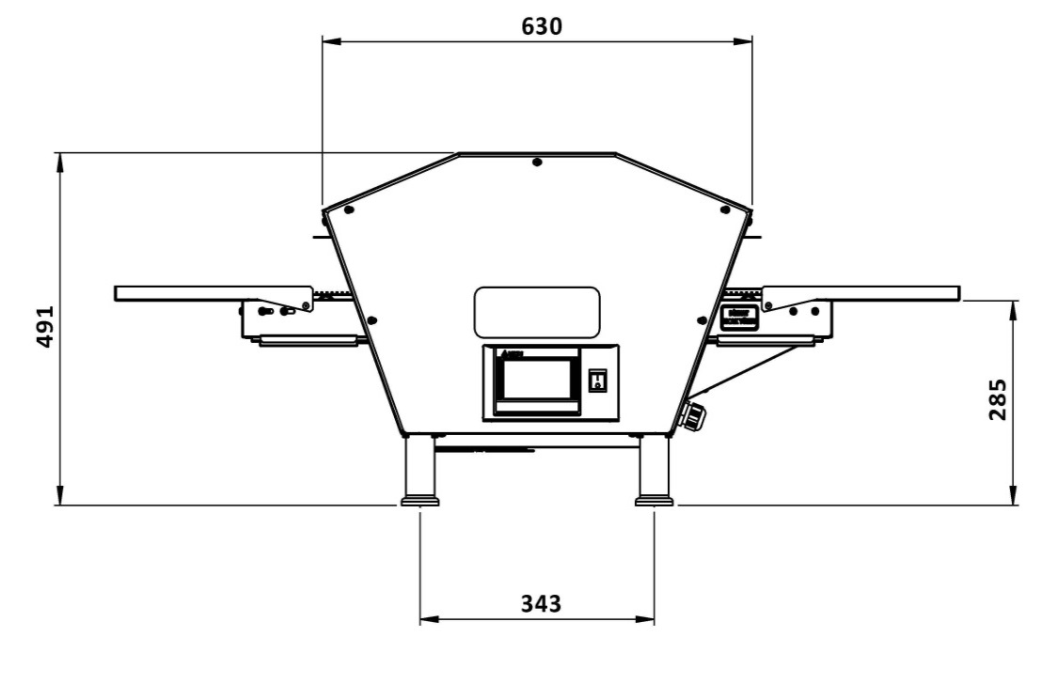 **Top View**

**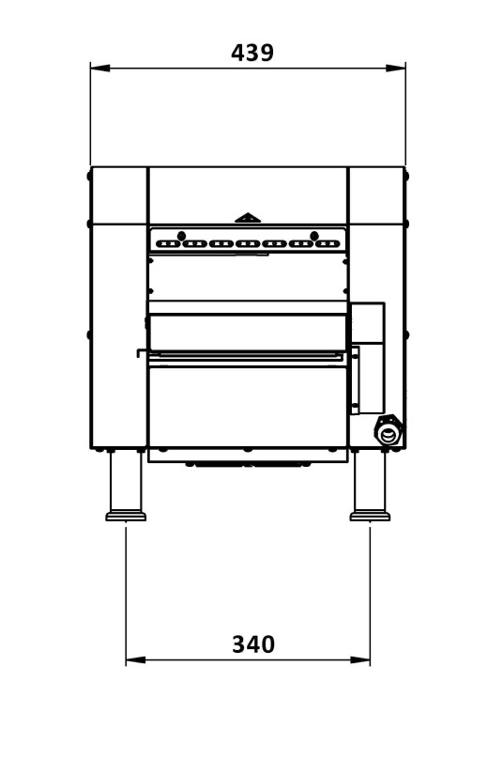  
 Front View Side View**

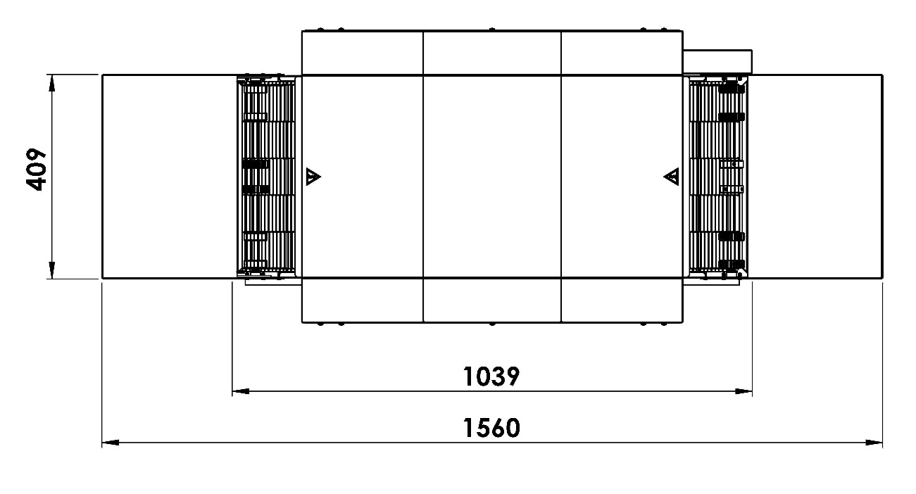**SEN 400 MINI**

**Top View**

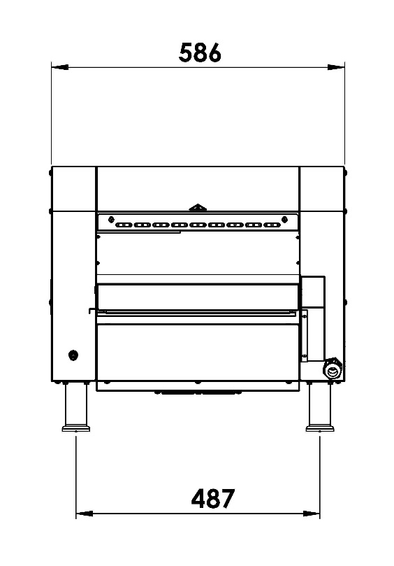

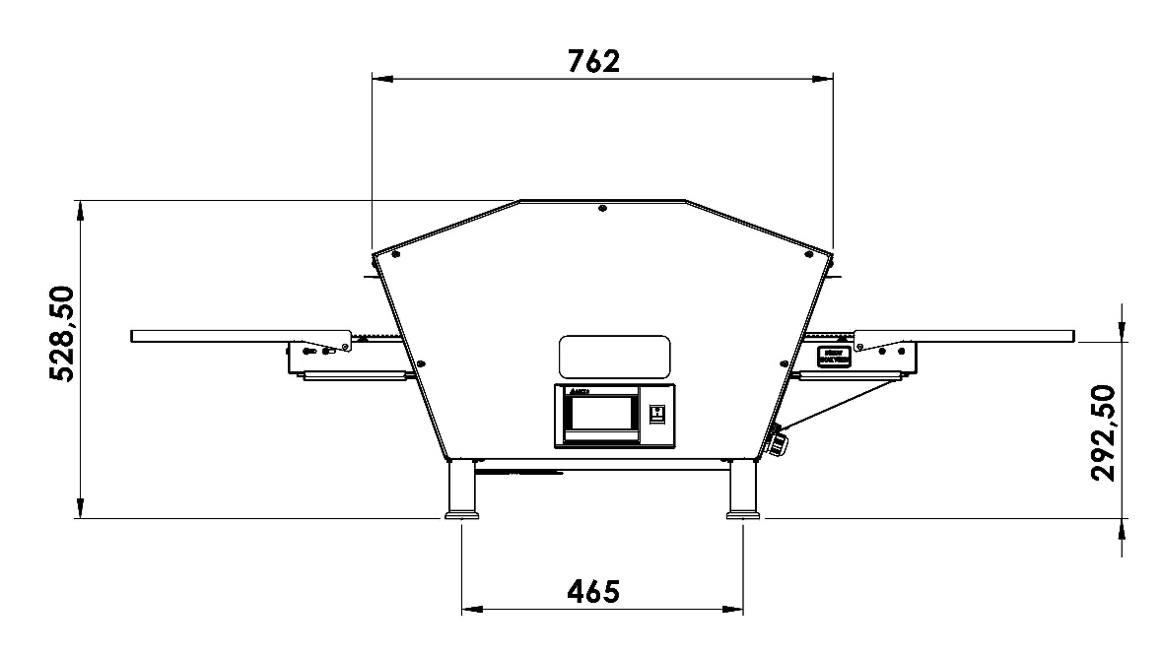

**Front View Side View**

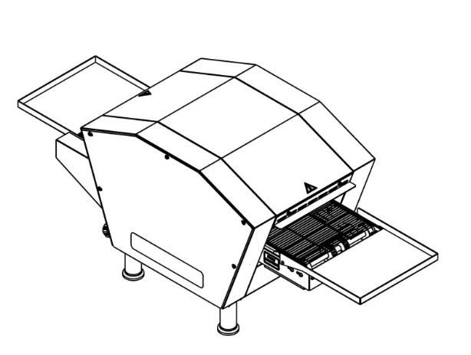

**SECTION 2: ASSEMBLE**

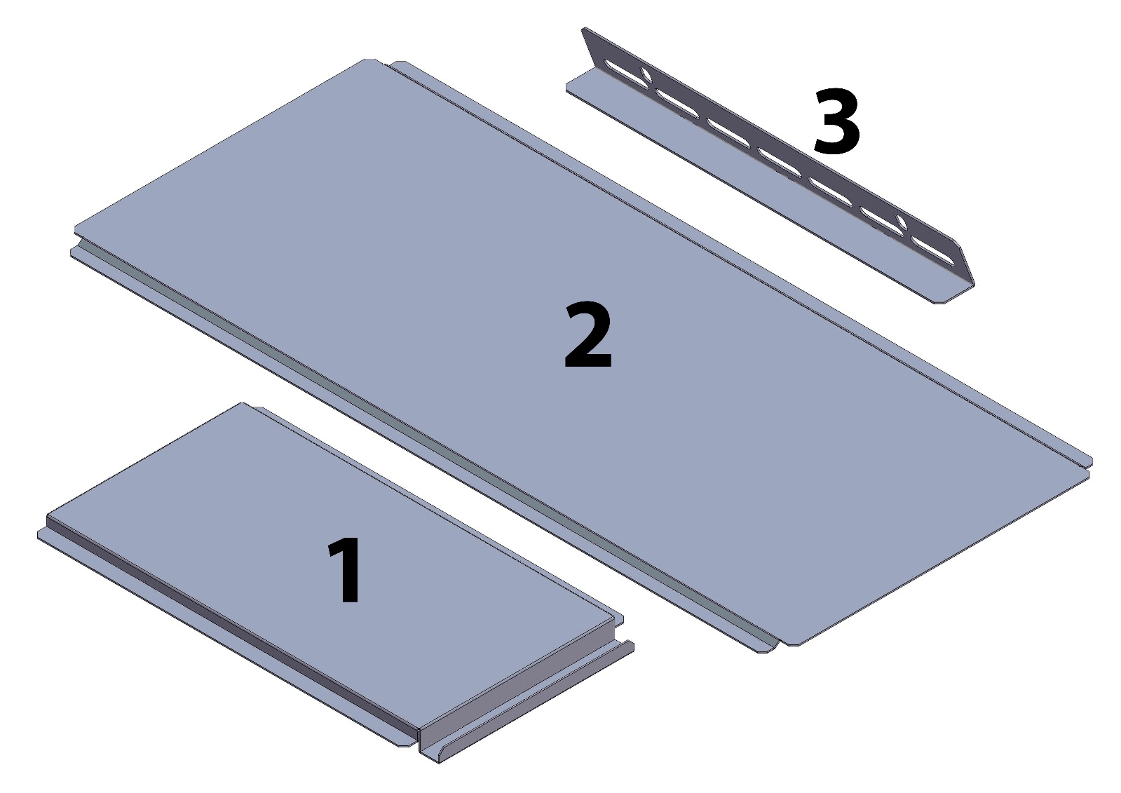

|  |  |  |
| --- | --- | --- |
| **NO** | **PART NAME** | **UNIT** |
| **1** | Waste Pan | 2 |
| **2** | Middle Waste Pan | 1 |
| **3** | Entry and Exit Cover Plate | 2 |

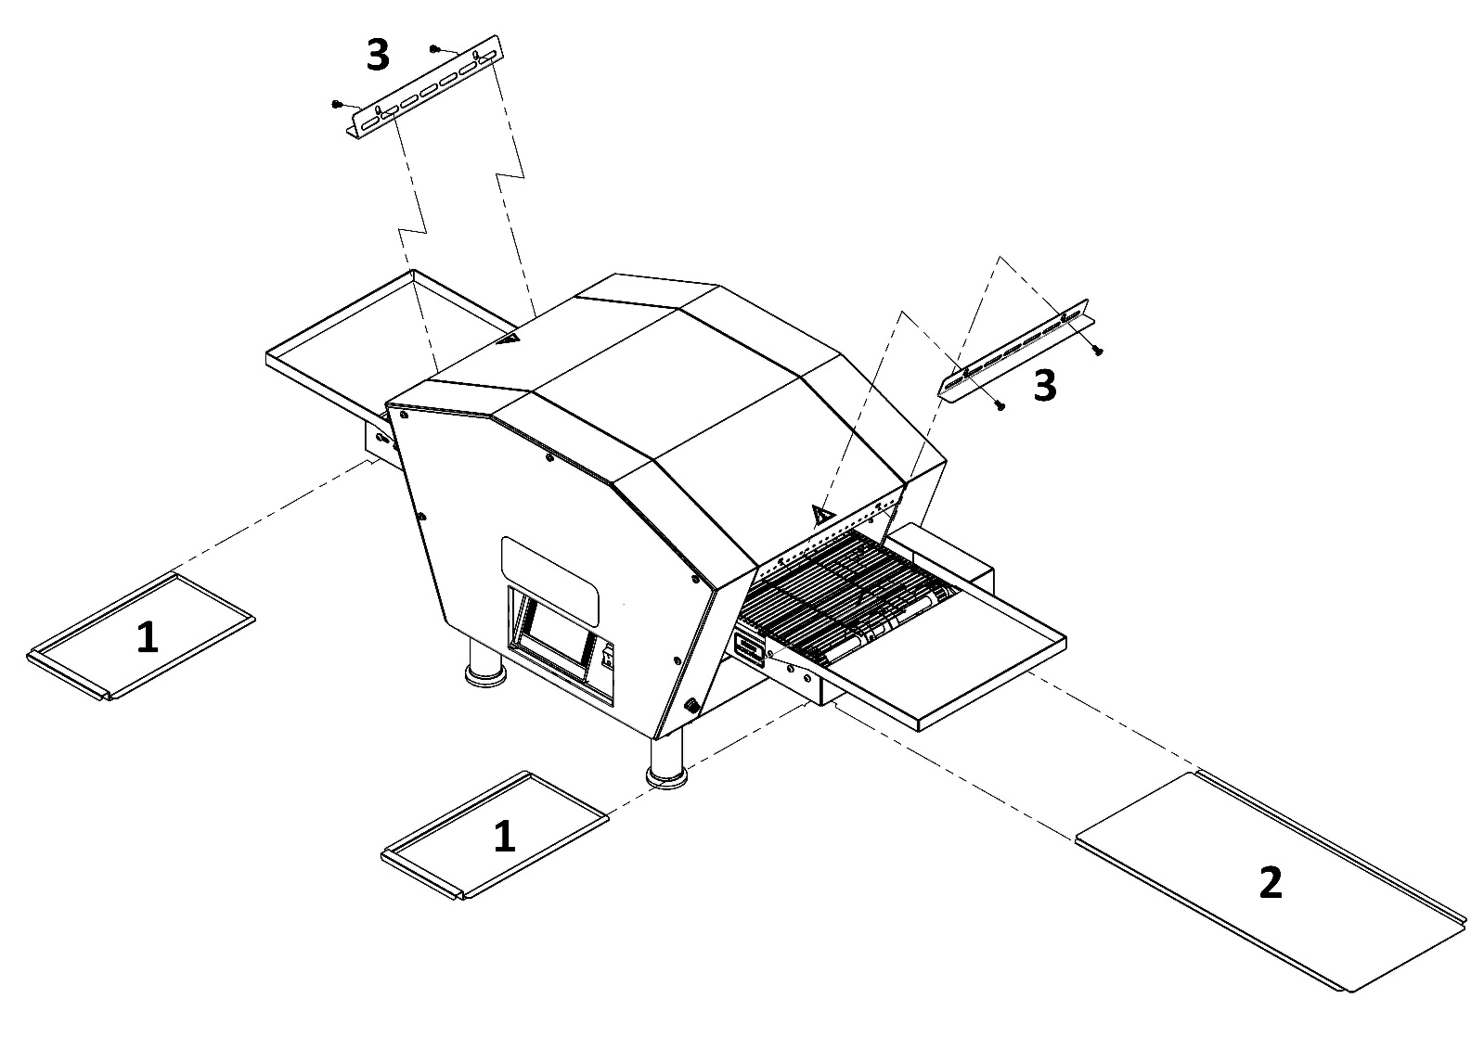**2.1 Sheet Assembly:**

Firstly mount the middle waste pan after than push up the waste pans to the body.

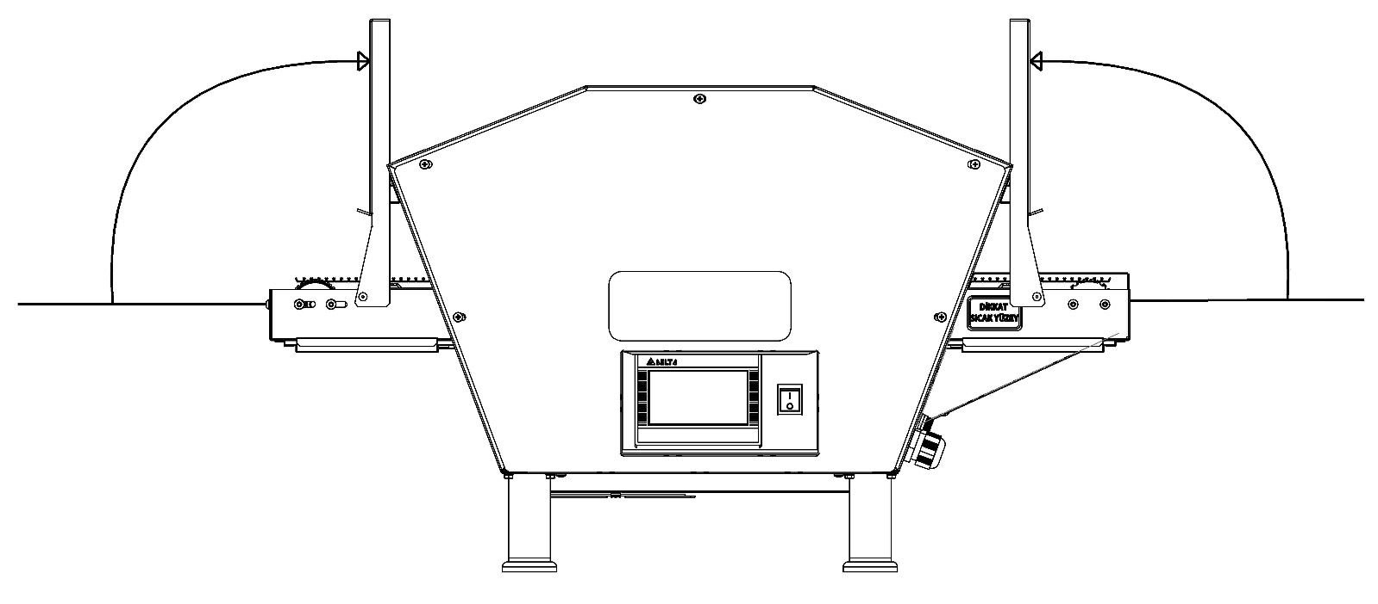

Product entrance and out sheet is foldable as shown in the figure.

**2.2 Belt Wire Assembly:**

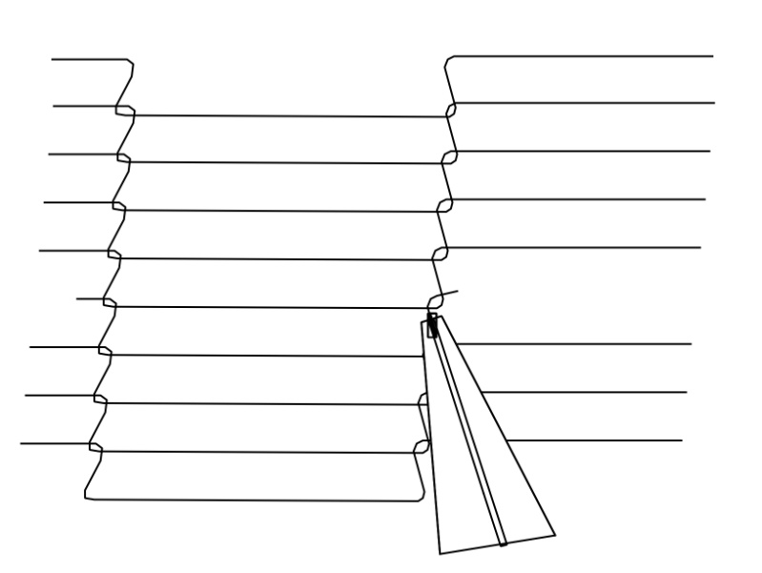

C:\Users\ARGE - MUSTAFA\Desktop\3.tif

2. Attached by pliers (Middle connecting wire)

1. Installed as shown in the figure. (Edge connecting wire left and right)

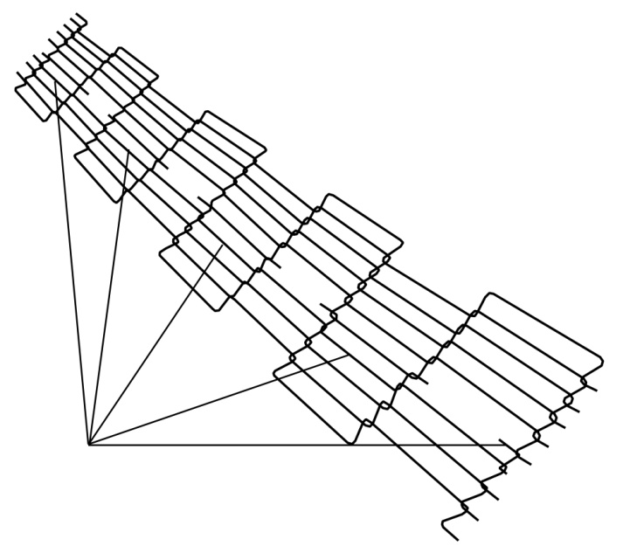C:\Users\ARGE - MUSTAFA\Desktop\4.tif

4. The final wire assembly

3. If belt wire problem appears, remove a wire as shown in the figure.

For disassembly, use every steps in reverse order.

***Note:*** *Clean the belt wire once a week or month for better performance.*  
  
 **SECTION 3: INSTRUCTIONS FOR USE**

**3.1 Space Requirements:**

The oven must have 130 mm of clearance from combustible surfaces.

NOTE: Do not install this (these) oven(s) in any area with an ambient temperature in excess of 40° C. Doing so will cause damage to the unit.

Fallow the instructions, if you want to use your oven properly for years.

You are ready for services to be connected. This should be done by a qualified electrician, or installer of your choice.

**DO NOT ATTEMPT TO OPERATE THE OVEN** until connection of utility service and installation has been fully inspected (START-UP CHECKOUT) by and Authorized Service Technician.

This is important service, In order to assure the oven(s) is/are properly installed and in working order. The warranty becomes effective upon verification of proper installation. The warranty shall not apply if the oven(s) is/are started up and operated prior to the “START-UP CHECKOUT” being performed by an Authorized Service Technician.



**DANGER!** Do not work around conveyor belt with long hair, loose clothing, or dangling

jewelry. Getting caught in the belt could result in serious injury.



**DANGER!** If the power supply cord appears to be damaged, do not attempt to operate

the unit. Contact a service agent or qualified electrician to repair!

**3.2 Installation Elements:**

**SEN 280 MİNİ;**  
3 x 16 A (K AUTOMAT) – Fuse

Cable section 2, 5 mm² (TTR CABLE – 3 FAZE / 1 NÖTR / 1 GROUNDING)

***NOTE:*** *TTR Cable is Flexible, shatterproof and loosen proof*

Grounding has to be proper.

Use regulator if voltage is high or low.

***NOTE:*** *If you fallow the above steps, assembly process can be made smoothly and quickly*

**SEN 400 MİNİ;**

3 x 20 A (K OTOMAT) – Fuse

Cable section 2, 5 mm² (TTR CABLE – 3 FAZE / 1 NÖTR / 1 GROUNDING)

***NOTE:*** *TTR Cable is Flexible, shatterproof and loosen proof*

Grounding has to be proper.

Use regulator if voltage is high or low.

***NOTE:*** *If you fallow the above steps, assembly process can be made smoothly and quickly*

**3.3 SEN 280-400 MINI Oven Technical Specifications Table:**

**SEN 280 MINI Oven Electricity Technical Specifications Table**

|  |  |  |  |  |  |  |  |  |
| --- | --- | --- | --- | --- | --- | --- | --- | --- |
| **Voltage** | **Faze** | **N** | **T (PE)** | **Cable Minimum Section** | **kW** | **Ampere Load** | | |
| **L1** | **L2** | **L3** |
| **400V 50/60 HZ** | **3** | **1** | **1** | **2,5 mm²** | **4,7 kW** | **7** | **7** | **7** |

**SEN 400 MINI Oven Electricity Technical Specifications Table**

|  |  |  |  |  |  |  |  |  |
| --- | --- | --- | --- | --- | --- | --- | --- | --- |
| **Voltage** | **Faze** | **N** | **T (PE)** | **Cable Minimum Section** | **kW** | **Ampere Load** | | |
| **L1** | **L2** | **L3** |
| **400V 50/60 HZ** | **3** | **1** | **1** | **2,5 mm²** | **8,3 kW** | **12** | **12** | **12** |

**SEN 280-400 MINI 3 FAZE CONNECTION**

**1**

**R**

**4**

**2**

**S**

**5**

**3**

**T**

**6**

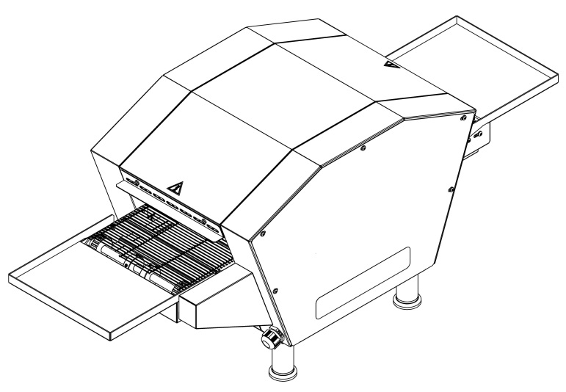

**R**

** 1 **

** 2 **

** 3 **

** 4 **

** 5 **

**S**

**T**

**Terminal  
Blog**

**N**

**PE**

**POWER CABLE ENTRANCE**

**SECTION 4: PROGRAMING - START & STOP**

All functions of the oven are controlled by a microprocessor. Oven needs programing before starting. Programing is described in the following pages.  
  
Switch on, the logo will appear on the screen.



Touch the logo, cooking menu will appear on the screen.

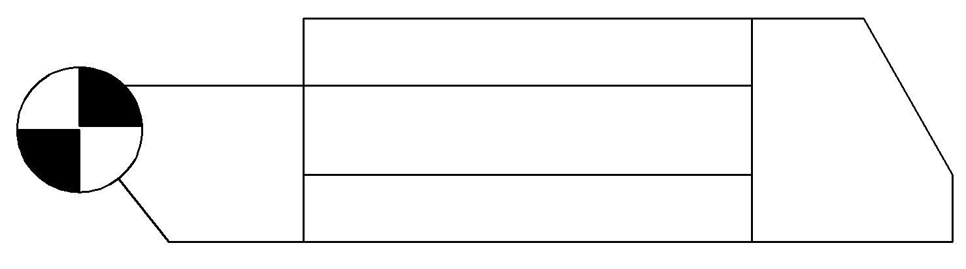

**LIST**

0

**+**

**−**

**APPLY**

**STOP**

**START**

**MENU**

PISIRME MENUSU

**COOKING TIME**

**MIN**

**SEC**

**PAUSE**

**80,0 %**

**GD  
23,8**

**SD  
120,0**

**50,0 %**

**STOP**

You must programming the oven at the first usage. Touch the “MENU” the main menu will appear on the screen

**LOGO**

**USER GUIDE**

**UTILITY PROGRAMS**

**COOKING PAGE**

**PROGRAM PAGE**

**MAIN MENU**

**TURKISH**

Touch the “**PROGRAM PAGE”**. The password screen will appear on the screen

Also you can change the language at the main menu.

**PASSWORD PAGE**

**PLEASE ENTER YOUR PASSWORD**

**PASSWORD**

0

**MENU**

Touch the Password box. Enter the 5555 code and apply. Wait until the PROGRAM PAGE appears.

**MENU**

**PROGRAM PAGE**

0

**NO**

**COOKING TIME**

**sec**

**min**

2

0

**TOP TEMPERATURE RATE**

**%**

**80,0**

**TEMPERATURE**

**°C**

**120,0**

**BOTTOM TEMPERATURE RATE**

**%**

**50,0**

Touch the “NO” box at the program page. Enter a code (e.g.: 1) after then, touch the empty box at the left side and enter a program name (e.g.: sandwich, bread, pide, pizza). After than touch the min and sec boxes and set the cooking time. After Than touch the bottom box and set the temperature. The upper heating zone can be set to the desired degree from 100°C to 600°C and the lower heating zone from 100°C to 500°C.

***Not: You can save more than one program. Touch the “NO” box at the up left corner and enter a new number for a new product.***

After set your cooking program. Touch the ‘MENU’ button on program page and return ‘MAIN MENU’ touch ‘COOKING PAGE’ button and return cooking menu.

**PIDE**

**MENU**

**−**

**+**



0

**COOKING TIME**

**LIST**

**APPLY**

COOKING MENU

**STOP**

**SEC**

**MIN**

**PAUSE**

**START**

**80,0 %**

**GD  
24,9**

**SD  
120,0**

**50,0 %**

**STOP**

Choose your product number with **+** and **-** buttons. After than touch the “APPLY”. When the settings comes to your screen, touch “START” and run the oven. When the oven run, the oven will warming up and the belt will begin to move. When the oven warming enough, “READY” appears on the screen. Than you can start cooking your product.

***Note:*** *if you press the “PAUSE” button when your product cooking, belt stops but temperature does not change.*

Touch to “LIST” icon if you want to see the product programs list with their numbers.

**MENU**

**LAHMACUN**

**1**

**L**

**I**

**S**

**T**

**PITA**

**2**

**BREAD**

**3**

**4**

**PIZZA**

**LAVAS**

**5**

**FISH**

**6**

**MEATBALL**

**7**

**2**

**4.1 Utility Programs:**

Touch the **“UTILITY PROGRAMS”** on main menu. “OPERATION STYLE” will appears on your screen.

**OPERATION STYLE**

**MENU**

**MANUAL OPERATION**

**CLEANING PROGRAM**

**STANDBY MODE**

**4.2 Manuel Operation:**

Touch the “**MANUAL OPERATION”** on “OPERATION STYLE” menu. Password page will appear on the screen. Enter the password “4444” and touch “ENTER” and wait. MANUAL PAGE will appear on the screen.

**MANUAL PAGE**

**MENU**



**sec**

**min**

**COOKING TIME**

15

0

**50,0**

**GD  
26,0**

**SD  
200,0**

**60,0**

**STOP**

**STOP**

**START**

**APPLY**

You can create a special cooking program at manual page. Firstly, touch the min and sec boxes and enter your cooking time. Than enter the cooking temperature at the box where is above of the “FAN” text. Touch the “APPLY” and “START” buttons. Oven will start cooking with your manual settings.

**4.3 Cleaning Program:**

Touch the “CLEANING PROGRAM” on “OPERATION STYLE” page. “OVEN WORKS ON CLEANING MODE” screen will appear on the screen. Cleaning Program mode burns the wastes of the oven and collect them into the waste pan. Cleaning Program mode works for 50 minutes. If necessary, touch the “QUIT CLEANING MODE” button to quit cleaning mode.

**4.4 Standby Mode:**

Touch the “STANDBY MODE” on “OPERATION STYLE” page. Oven cooks on standby mode with %25 energy saving.

Ensures that the furnace is ready in certain usage ranges. Exit the “STANDBY MODE” by tapping the “STANDBY MODE” button when required.

**4.5 Warnings:**

1. When the temperature limit is exceeded, oven gives warning as “TEMPERATURE LIMIT EXCEEDED”.

2. If the product does not cook enough, fix the cooking time and temperature settings.

3. If the product over cook, fix the cooking time and temperature settings.

4. If cooking time and temperature values are normal and products still don’t cook or over cook, call us.

**4.6 Shutdown:**

Touch the “STOP” button, “SWITCH OFF” appears on the screen. Than you can swıtch off.

**4.7 Error / Warnings Messages:**

Our Machines have controlled warning messages. If unexpected errors occur, error messages appear on the screen.  
  
**4.7.1 Temperature Determine Failure:**

If any temperature value couldn’t detected by control panel, “Temperature Determine Failure” message appears.  
  
**4.7.2 Temperature Does Not Rise:**

If Oven temperature doesn’t rise for five minutes, “Temperature does not Rise” message appears.  
 **4.7.3 Belt Engine Failure:**

“Belt Engine Failure” message appears when a problem with the conveyor motor.

**4.7.4 Temperature Limit Exceeded:**

If the temperature value rise up over the upper heating zone 650 °C, If the temperature value rise up over the lower heating zone 550 °C “Temperature Limit Exceeded” message appears

**4.7.5 Low Battery Warning:**

“Low Battery Warning” message appears, when battery low.

**4.7.6 Ready:**

“Ready” message appears when oven temperature has reached desired degree.

**4.8 Functions:   
  
4.8.1 Temperature Switch:**

Our ovens have temperature switches for your safety. That switches are designed to prevent potential damages of overheating. It works automatically.



**WARNING!** Do not use an external switch to do not block to the temperature switch.

**4.8.2 Electrical Installations:**



**WARNING!** Grounding must be done properly before install of the oven. Electrical damage causes fatal injuries or death.

**For All Foreign Countries:**

Apply local electrical rules.

1. All Poles connect switches have 3mm wide.
2. Grounding cable head is back on the oven.

If you use more than one oven (double or triple) each oven must has its own switch and all switches should be close together.

**4.8.3 Operator Maintenance:**

**WARNING!** Disconnect power supply before servicing or cleaning this oven Safeguard power so it cannot be accidentally restored. Failure to do so could result in dismemberment, electrocution, or fatal injury. There is more than one power supply connection point when ovens are stacked. Make sure that all switches are in the “OFF” position before cleaning or maintenance.

To maintain maximum efficiency of the oven, it is necessary to keep it clean, all ventilation louvers on the oven must be cleaned regularly. Oven use and type of product will actually determine the frequency of cleaning. The conveyor drive chain should be checked during the weekly cleaning cycle to see if it has become loose. Loose chain operation will DAMAGE the conveyor drive motor.

If the oven fails to operate, check the circuit breaker to be sure it is turned on. Be sure that circuit breaker is ok before you call the Authorized Service Agency. The name and phone number of the Authorized Service Agency should be located at the bottom of the data plate.

**4.8.4 Cleaning Instructions:**

The oven contains electrical components. Before cleaning the oven, switch off and disconnect the oven from the electrical supply.

No electrical components should be subjected to moisture. It is, therefore, important that the oven is wiped down carefully. NEVER throw buckets of water over the oven or subject it to pressure washing from a hose or a pressure spray. If water or other liquid is spilled on the oven, make sure that none has entered the control box area before switching on. If in doubt, call your service company.



**WARNING!** Oven must be cool. Do not use power-cleaning equipment, steel wool, or wire brushes on stainless steel surfaces.

**DAILY;**

1. Clean exterior surfaces of the oven by wiping it down with a mild detergent and clean water, or a commercial stainless cleaner.
2. Clean crumb pans and guards by washing with a mild detergent solution and rinsing with clean water.
3. Clean the interior by sweeping up all loose particles, then wash with a mild detergent solution and rinse with clean water.
4. Clean the conveyor belt by wiping with a clean cloth or brushing with a soft wire brush

On exterior of oven, deposits of baked-on splatter, oil, grease, or light discoloration may be removed with any of several commercial cleaners. Consult with your local supplier.

**MONTHLY;**

1. Remove fingers, disassemble and clean. See “Finger Assembly” section for more information.
2. Remove conveyor, disassemble and clean. See “Conveyor Installation” section for more information.

***NOTE:*** *Be sure to clean and inspect the ventilation hood in accordance with the ventilation hood manufacturer’s specifications.*

**4.8.5 Protective Maintenance:**

Although this oven has been designed to be as trouble free as possible, periodic Preventive Maintenance is essential to maintain peak performance. It is necessary to keep the motors, fans, and electronic controls free of dirt, dust and debris to insure proper cooling. Overheating is detrimental to the life of all components mentioned.

The periodic intervals for preventative cleaning may vary greatly depending upon the environment in which the oven is operating.

You must discuss the need for Preventive Maintenance with your Authorized Service Company to establish a proper program.

**SECTION 5: COOKED PRODUCTS**

**5.1 Some of the Cooked Products**

* Brownie
* Hamburger
* Hot Dogs
* Omelet
* Pancakes
* Mixed Vegetable Plate
* Steakhouse
* Skewers
* Meatball
* Potato
* Borek
* Chicken Wings
* Grilled Chicken
* Chicken Saute
* Bread
* Breakfast
* Fish
* Seafood
* Pizza
* Lavas
* Lahmacun
* Pita
* Kunefe
* Chocolate Cookie
* Pie
* Etc. Many Foods

**5.3 Total Cooking Calculation:**

**Sample 1:**

Oven Chamber Length: 603 mm.  
Cooking Time: 2 min.  
Pan Length: 100 mm.

Pan Length   
(A)

**100**

**1**

**2**

**3**

**2**

**1**

**Örnek 2:**

Oven Chamber Length: 603 mm.  
Cooking Time: 5 dk.  
Pan Length: 250 mm.

**250**

Pan Length   
(B)

**SECTION 6: SPARE PARTS MANUAL**

**SPARE**

**PARTS**

**MANUAL**

**(SEN 280)**

**SEN 280**

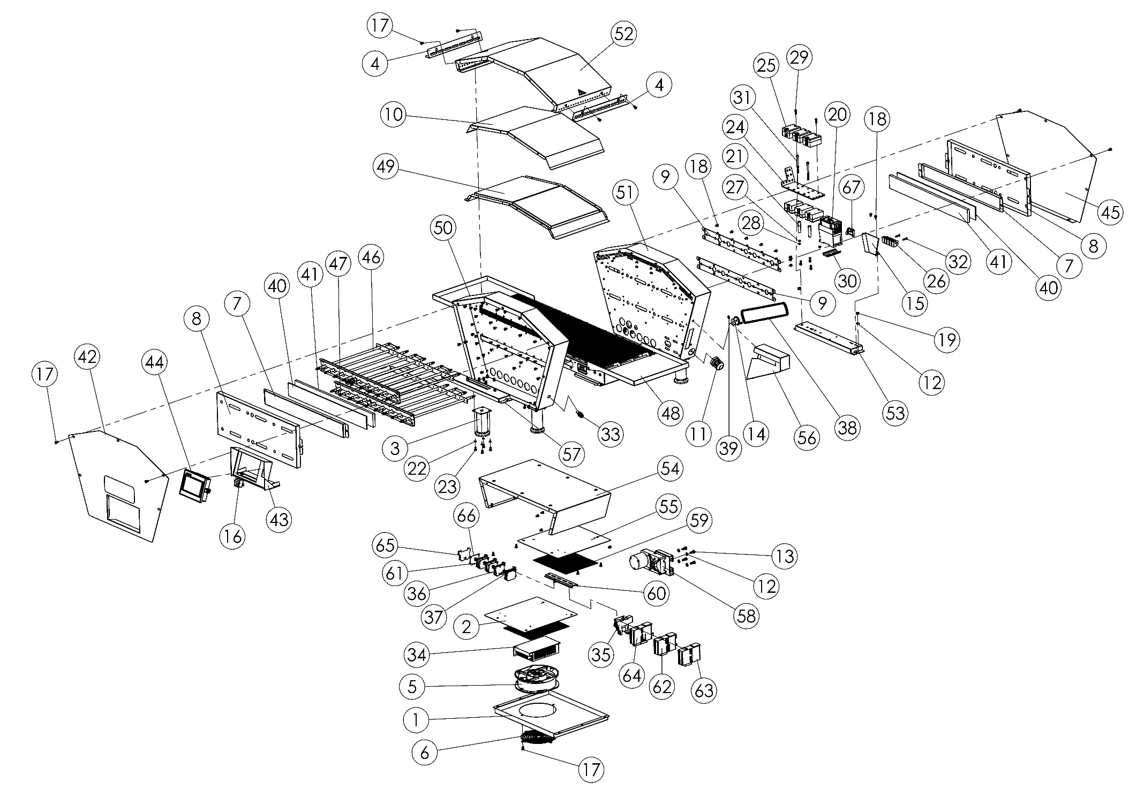

|  |  |  |  |  |  |  |  |  |
| --- | --- | --- | --- | --- | --- | --- | --- | --- |
| **ITEM** | **SPARE PART NUMBER** | **SPARE PART DESCRIPTION** | **UNIT** |  | **ITEM** | **SPARE PART NUMBER** | **SPARE PART DESCRIPTION** | **UNIT** |
| **1** | 08046 | BOTTOM COVER SHEET | 1 |  | **35** | 08093 | RELAY | 1 |
| **2** | 08048 | AIR GAP SHEET | 1 |  | **36** | 01385 | TERMINAL (GREY) | 2 |
| **3** | 08086 | LEG | 4 |  | **37** | 00294 | TERMINAL (BLUE) | 4 |
| **4** | 08055 | ENTRY AND EXIT COVER PLATE | 2 |  | **38** | 08098 | CHAIN | 1 |
| **5** | 08061 | FAN | 1 |  | **39** | 02014 | SETSKUR | 2 |
| **6** | 08060 | FAN WIRE | 1 |  | **40** | 08111 | IZOLATION | 2 |
| **7** | 08034 | IZOLATION SHEET | 2 |  | **41** | 08112 | IZOLATION | 2 |
| **8** | 08010 | COVER SHEET | 2 |  | **42** | 08006M | RIGHT COVER | 1 |
| **9** | 08030 | FIX PLATE | 4 |  | **43** | 08008M | SCREEN SHEET | 1 |
| **10** | 08043 | IZOLATION SHEET | 1 |  | **44** | 08009M | SCREEN | 1 |
| **11** | 08054 | RECORD | 1 |  | **45** | 08010M | LEFT COVER | 1 |
| **12** | 00042 | WASHER | 8 |  | **46** | 08005M | TOP REZISTANCE | 1 |
| **13** | 08075 | BOLT | 4 |  | **47** | 08004M | BOTTOM REZISTANCE | 1 |
| **14** | 08151 | CHAIN GEAR | 1 |  | **48** | M00357 | CONVEYOR | 1 |
| **15** | 08064 | GUARD SHEET | 1 |  | **49** | 08011M | TOP IZOLATION SHEET | 1 |
| **16** | 08066 | BUTTON | 1 |  | **50** | 08013M | LEFT EDGE SHEET | 1 |
| **17** | 00046 | BOLT | 28 |  | **51** | 08014M | RIGHT EDGE SHEET | 1 |
| **18** | 08074 | SCREW | 129 |  | **52** | 08015M | TOP COVER | 1 |
| **19** | 01305 | NUT | 4 |  | **53** | 08016M | RIGHT BASE SHEET | 1 |
| **20** | 01615 | CONTACTOR | 6 |  | **54** | 08017M | BOTTOM MID SHEET | 1 |
| **21** | 08083 | PIPE | 1 |  | **55** | 08019M | BOTTOM AIR GAP SHEET | 1 |
| **22** | 01685 | WASHER | 2 |  | **56** | 08020M | CHAIN GUARD SHEET | 1 |
| **23** | 00048 | BOLT | 18 |  | **57** | 08038M | LEFT BASE SHEET | 1 |
| **24** | 08082 | SSR SHEET | 18 |  | **58** | 00089M | ENGINE | 1 |
| **25** | 01822 | SSR RELAY | 1 |  | **59** | 08165 | BOTTOM AIR GAP SHEET | 2 |
| **26** | 08096 | TERMINAL | 6 |  | **60** | 01030 | TERMINAL RAIL | 1 |
| **27** | 01296 | WASHER | 1 |  | **61** | 00295 | TERMINAL (RED) | 2 |
| **28** | 02634 | NUT | 6 |  | **62** | 00152M | HEAT CARD | 1 |
| **29** | 01184 | BOLT | 6 |  | **63** | 01440M | HEAT CARD | 1 |
| **30** | 08073 | TERMINAL RAIL | 6 |  | **64** | 08007M | PLC | 1 |
| **31** | 08078 | BOLT | 2 |  | **65** | 00293 | TERMINAL | 1 |
| **32** | 02584 | BOLT | 2 |  | **66** | 01384 | GROUNDING | 5 |
| **33** | 08080 | FUSE HOLDER | 1 |  | **67** | 00292 | LIMITER | 1 |
| **34** | 08095 | POWER SOURCE | 1 |  |  |  |  |  |

**SEN 280 MINI SPARE PARTS LIST**

**M00357 BELT**

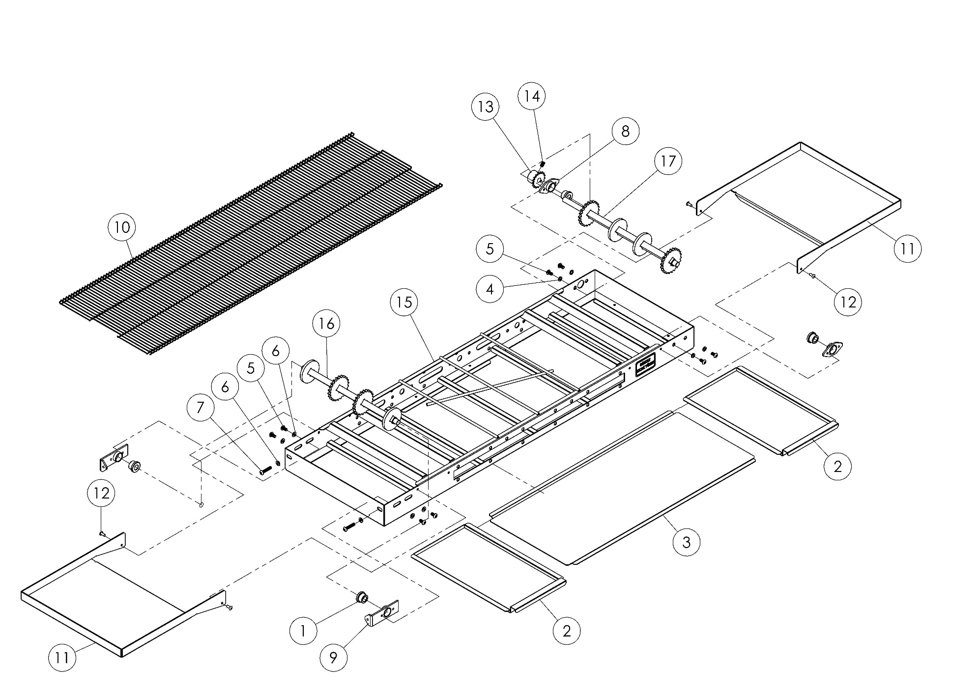

**M00357 (BELT) SPARE PARTS LIST**

|  |  |  |  |
| --- | --- | --- | --- |
| **ITEM** | **SPARE PART NUMBER** | **SPARE PART DESCRIPTION** | **UNIT** |
| 1 | 08006 | SHAFT | 4 |
| 2 | 08004 | WASTE PAN | 2 |
| 3 | 08005 | WASTE PAN | 1 |
| 4 | 01685 | WASHER | 4 |
| 5 | 08087 | BOLT | 8 |
| 6 | 08088 | WASHER | 6 |
| 7 | 08089 | BOLT | 2 |
| 8 | 08001M | BELT BEARING | 2 |
| 9 | 08002M | BELT BEARING | 2 |
| 10 | 08003M | WIRE BELT | 1 |
| 11 | 08070 | EXIT PAN | 2 |
| 12 | 01529 | RIVET | 4 |
| 13 | 08151 | GEAR | 1 |
| 14 | 02014 | SETSKUR | 2 |
| 15 | 08012M | CONVEYOR CHASSIS | 1 |
| 16 | 00469M | IDLE SHAFT | 1 |
| 17 | 00470M | DRIVE SHAFT | 1 |

**SPARE**

**PARTS**

**MANUAL**

**(SEN 400)**

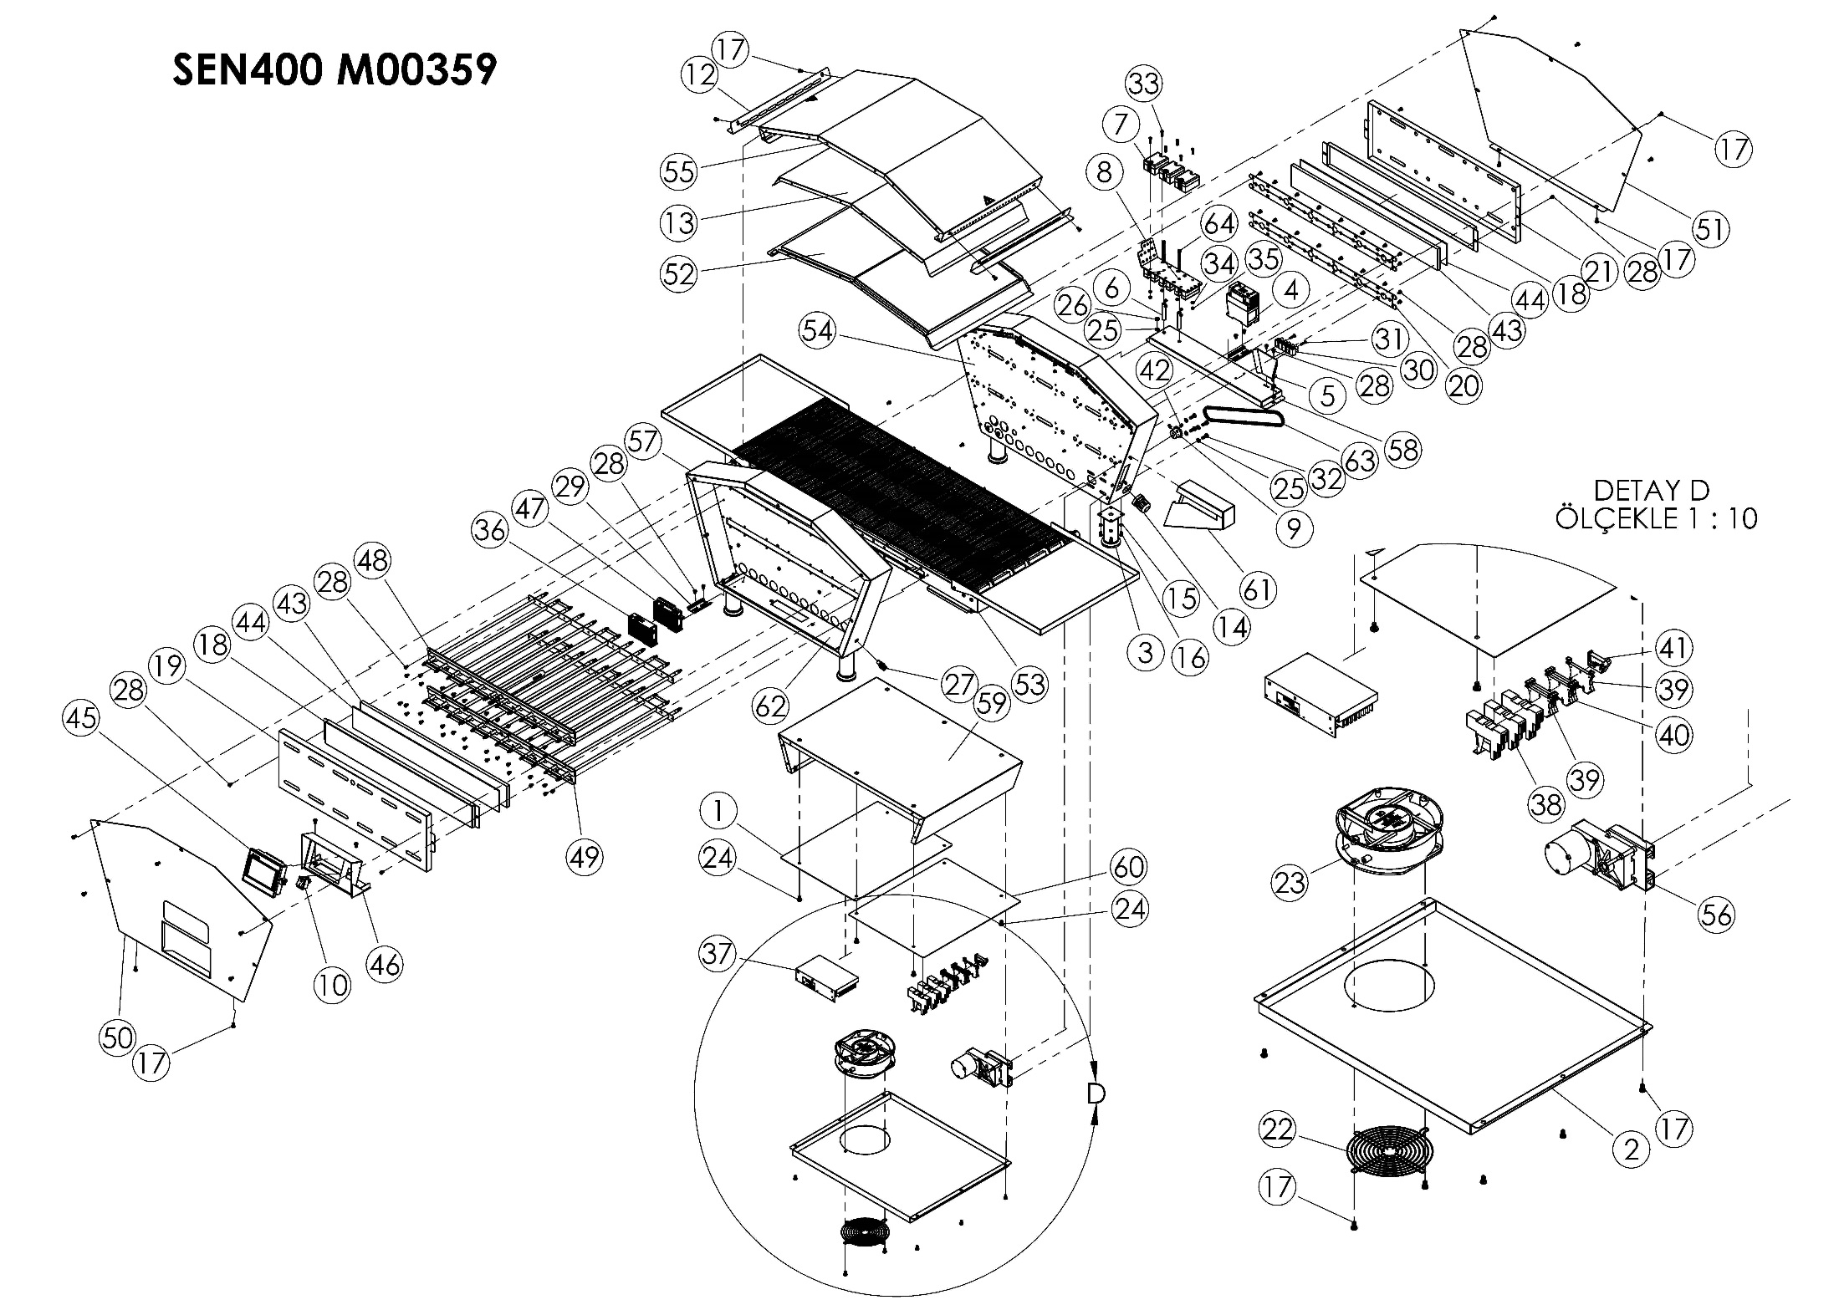

|  |  |  |  |  |  |  |  |  |
| --- | --- | --- | --- | --- | --- | --- | --- | --- |
| **ITEM** | **SPARE PART NUMBER** | **SPARE PART DESCRIPTION** | **UNIT** |  | **ITEM** | **SPARE PART NUMBER** | **SPARE PART DESCRIPTION** | **UNIT** |
| **1** | 08121 | AIR GAP SHEET | 1 |  | **33** | 01184 | BOLT | 6 |
| **2** | 08122 | BOTTOM COVER SHEET | 1 |  | **34** | 01296 | WASHER | 6 |
| **3** | 08086 | LEG | 4 |  | **35** | 02634 | NUT | 6 |
| **4** | 08081 | CONTACTOR | 1 |  | **36** | 01287 | MAIN HEAT CARD | 1 |
| **5** | 08064 | GUARD SHEET | 1 |  | **37** | 08095 | POWER SOURCE | 1 |
| **6** | 08083 | PIPE | 2 |  | **38** | 08093 | RELAY | 3 |
| **7** | 01822 | SSR RELAY | 6 |  | **39** | 00295 | TERMINAL (RED) | 4 |
| **8** | 08082 | SSR SHEET | 1 |  | **40** | 00294 | TERMINAL (BLUE) | 3 |
| **9** | 08056 | CHAIN GEAR | 1 |  | **41** | 00292 | LIMITER | 1 |
| **10** | 08091 | BUTTON | 1 |  | **42** | 02014 | SETSKUR | 2 |
| **11** | 00278 | BOLT | 2 |  | **43** | 08136 | IZOLATION | 2 |
| **12** | 08126 | COVER SHEET | 2 |  | **44** | 08137 | IZOLATION | 2 |
| **13** | 08124 | IZOLATION SHEET | 1 |  | **45** | 08009M | SCREEN | 1 |
| **14** | 08054 | RECORD | 1 |  | **46** | 08008M | SCREEN SHEET | 1 |
| **15** | 01685 | WASHER | 18 |  | **47** | 08007M | PLC | 1 |
| **16** | 00048 | BOLT | 18 |  | **48** | 08022M | TOP REZISTANCE | 1 |
| **17** | 00046 | BOLT | 26 |  | **49** | 08023M | BOTTOM REZISTANCE | 1 |
| **18** | 08117 | IZOLATION SHEET | 2 |  | **50** | 08024M | RIGHT COVER | 1 |
| **19** | 08149 | CLOSİNG CASE | 1 |  | **51** | 08025M | LEFT COVER | 1 |
| **20** | 08118 | HOLDER SHEET | 4 |  | **52** | 08026M | TOP IZOLATION SHEET | 1 |
| **21** | 08116 | COVER SHEET | 2 |  | **53** | SEN400 M00360 | BELT | 1 |
| **22** | 08060 | FAN WIRE | 1 |  | **54** | 08029M | LEFT WEDGE SHEET | 1 |
| **23** | 08061 | FAN | 1 |  | **55** | 08030M | TOP COVER SHEET | 1 |
| **24** | 08077 | BOLT | 6 |  | **56** | 00089M | ENGINE | 1 |
| **25** | 00042 | WASHER | 8 |  | **57** | 08028M | LEFT WEDGE SHEET | 1 |
| **26** | 01305 | NUT | 4 |  | **58** | 08033M | RIGHT BASE SHEET | 1 |
| **27** | 08080 | FUSE HOLDER | 1 |  | **59** | 08031M | LEFT MID SHEET | 1 |
| **28** | 08074 | SCREW | 152 |  | **60** | 08036M | BOTTOM AIR GAP SHEET | 1 |
| **29** | 08073 | TERMINAL RAIL | 2 |  | **61** | 08037M | CHAIN GUARD SHEET | 1 |
| **30** | 08096 | TERMINAL | 1 |  | **62** | 08039M | LEFT BASE SHEET | 1 |
| **31** | 02584 | BOLT | 2 |  | **63** | 08142 | CHAIN | 1 |
| **32** | 08075 | BOLT | 4 |  | **64** | 08078 | BOLT | 2 |

**SEN 400 MINI SPARE PARTS LIST**

**M00360 BELT**

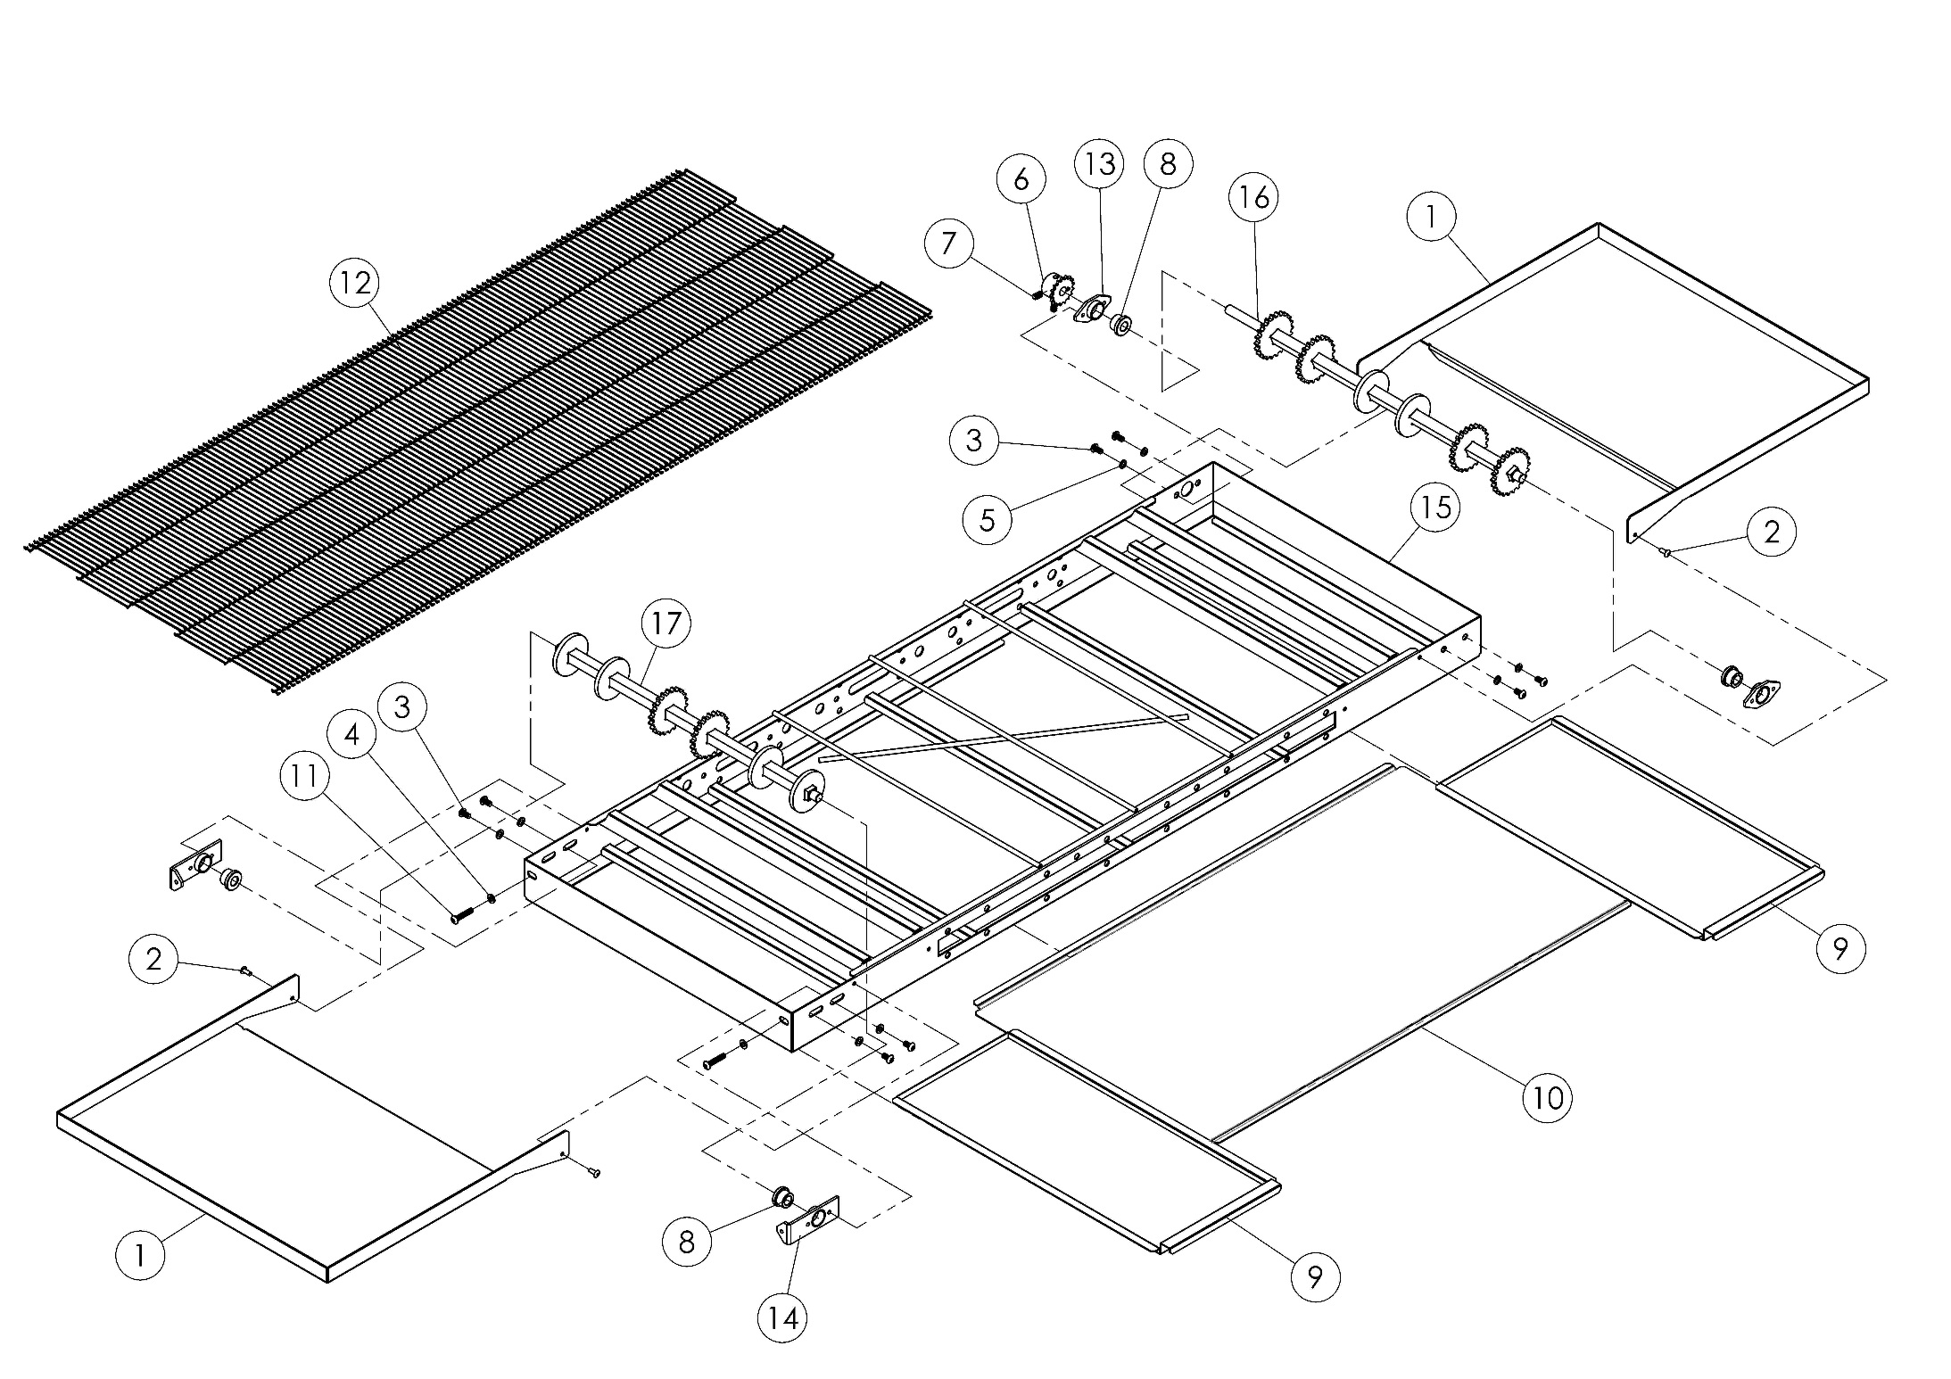

|  |  |  |  |
| --- | --- | --- | --- |
| **ITEM** | **SPARE PART NUMBER** | **SPARE PART DESCRIPTION** | **UNIT** |
| 1 | 08052 | EXIT PAN | 2 |
| 2 | 01529 | RIVET | 4 |
| 3 | 08087 | BOLT | 8 |
| 4 | 08088 | WASHER | 6 |
| 5 | 01685 | WASHER | 4 |
| 6 | 08056 | CHAIN GEAR | 1 |
| 7 | 02014 | SETSKUR | 2 |
| 8 | 08006 | SHAFT | 4 |
| 9 | 08004 | WASTE PAN | 2 |
| 10 | 08058 | WASTE SHEET | 1 |
| 11 | 08089 | BOLT | 2 |
| 12 | 08040M | BELT | 1 |
| 13 | 08001M | BELT BEARING | 2 |
| 14 | 08002M | BELT BEARING | 2 |
| 15 | 00389M | BELT CHASSIS | 1 |
| 16 | 00467M | DRIVE SHAFT | 1 |
| 17 | 00468M | IDLE SHAFT | 1 |

**M00360 (BELT) SPARE PARTS LIST**

**SECTION 7: ELECTRICAL DIAGRAM**

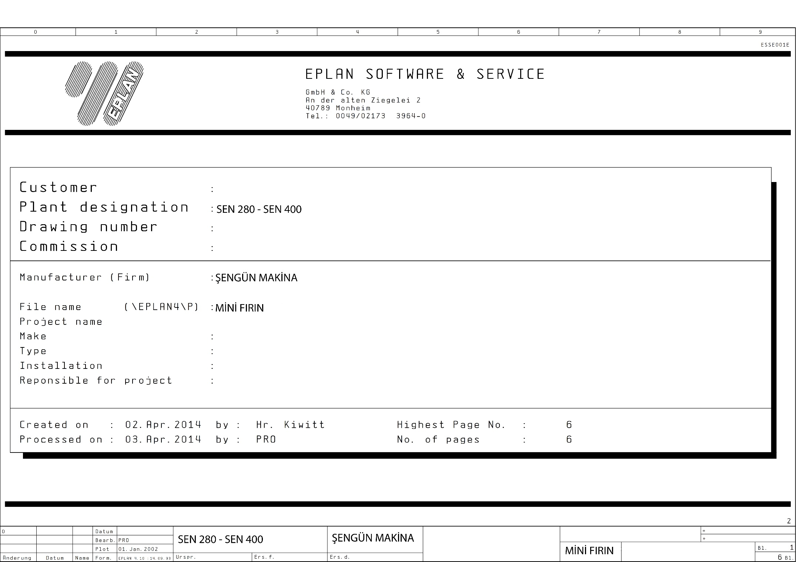

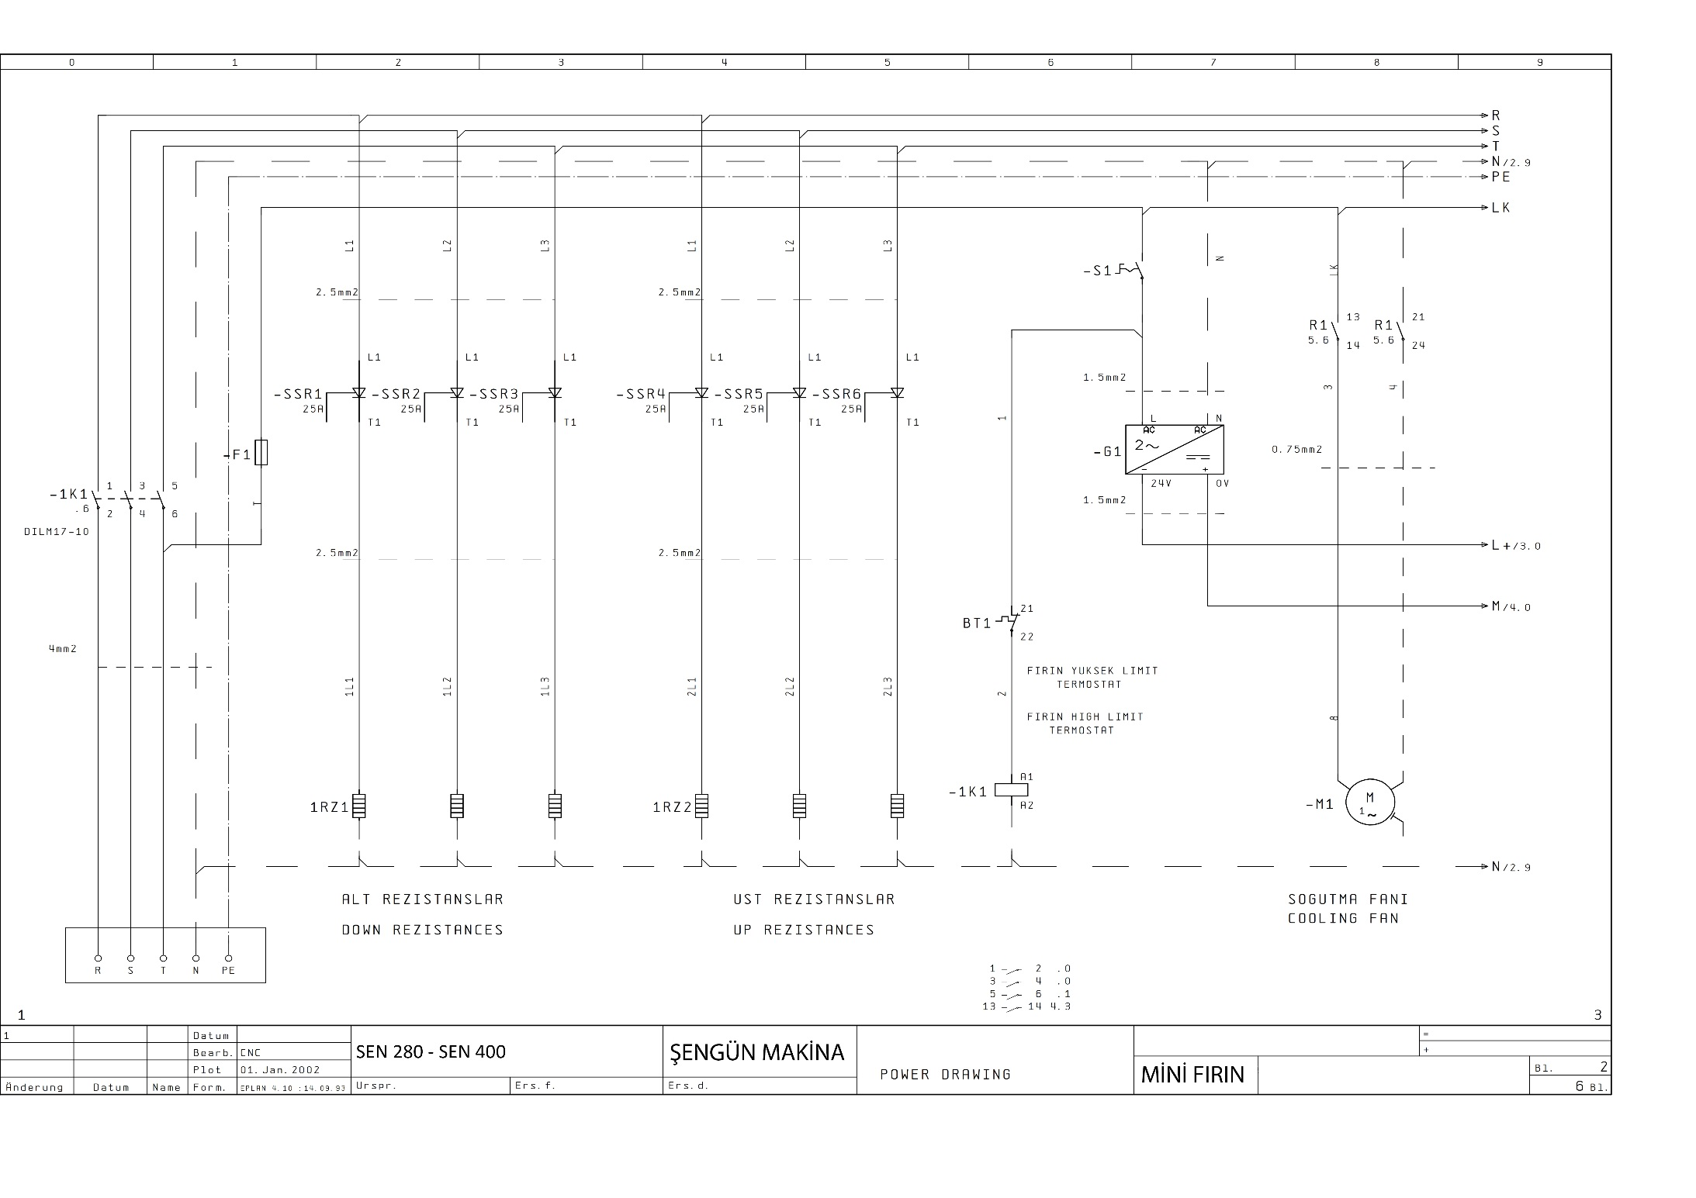

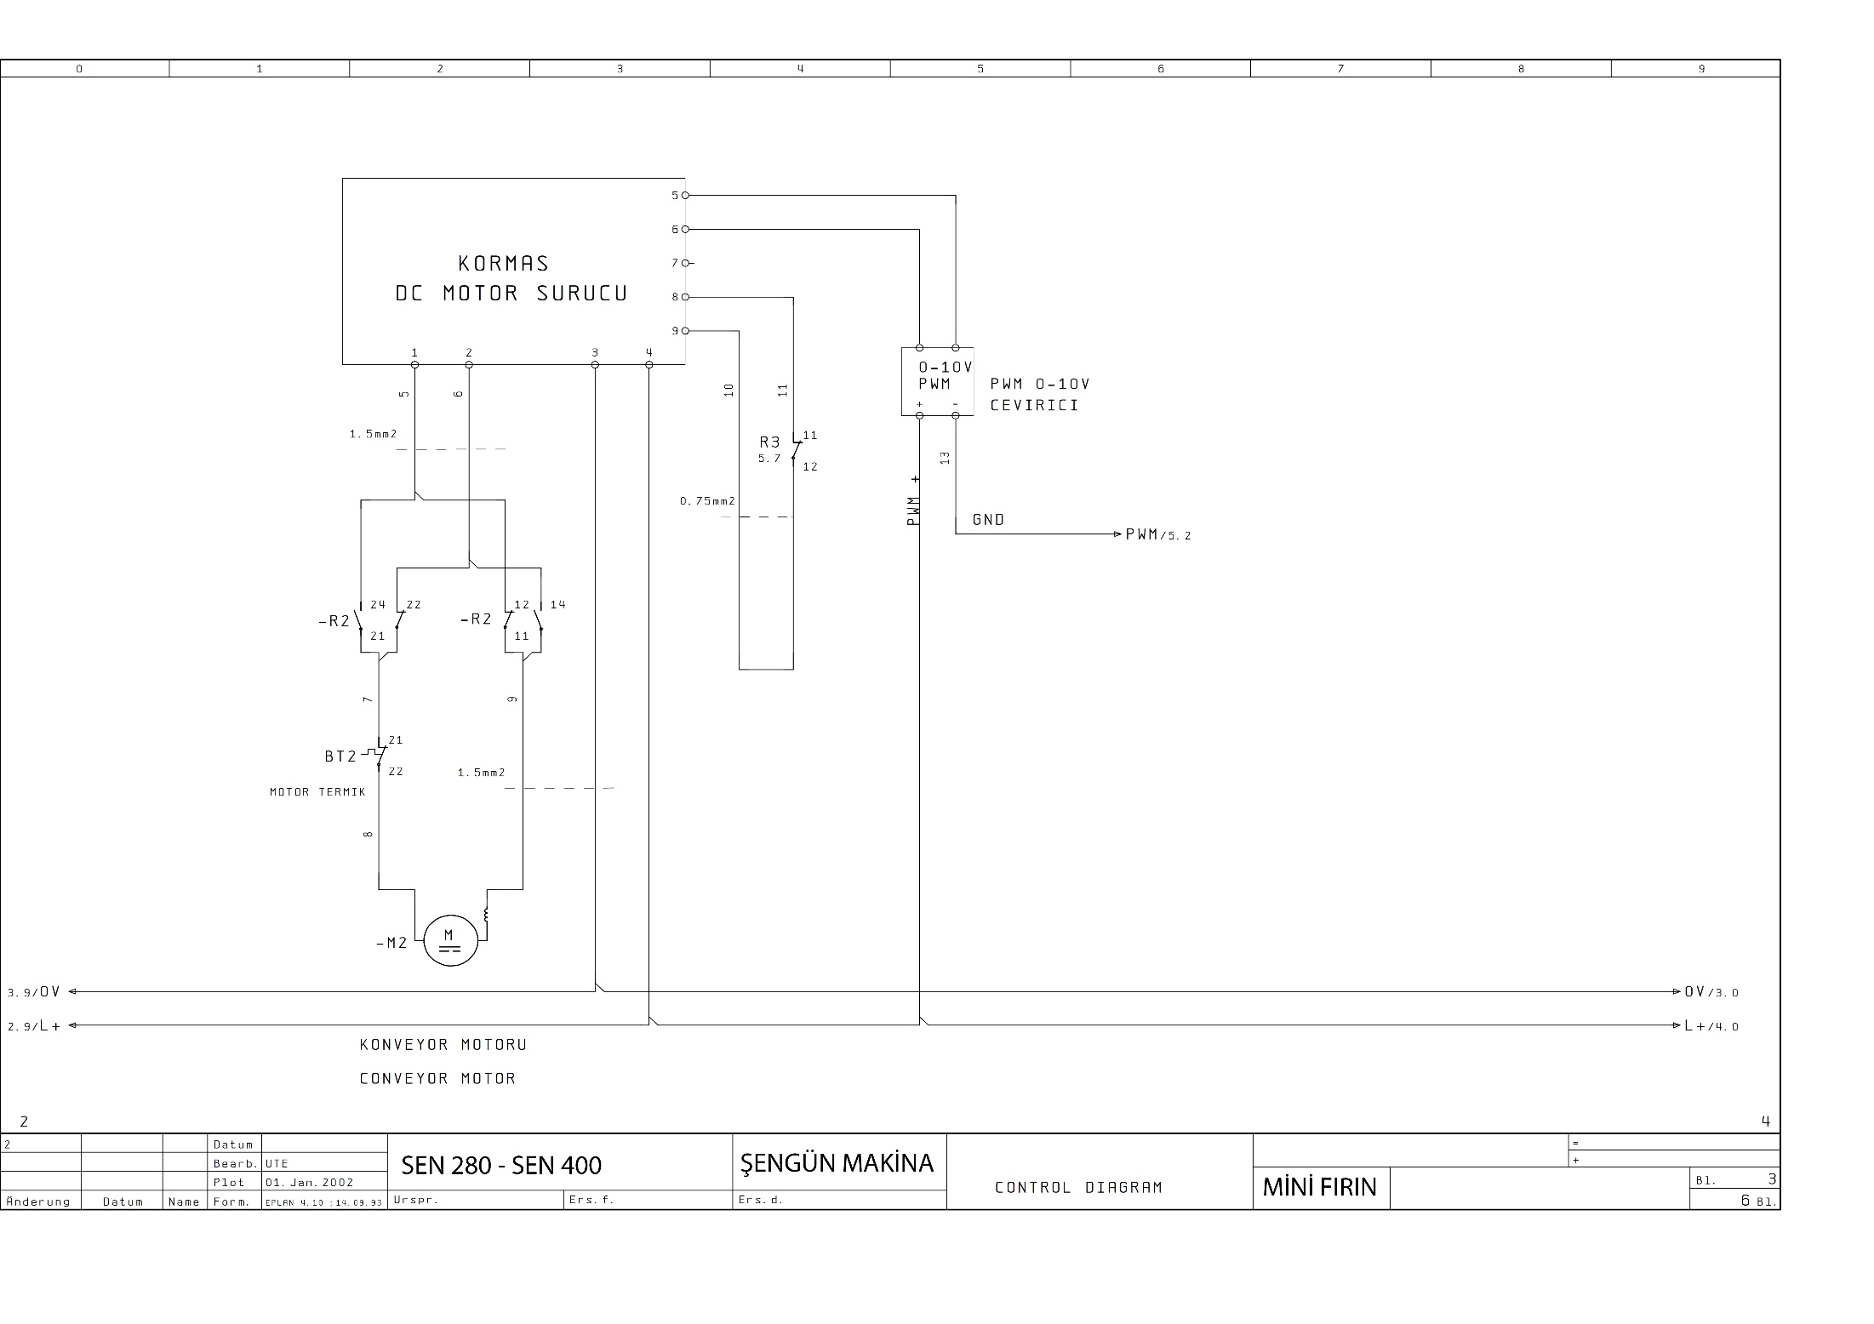

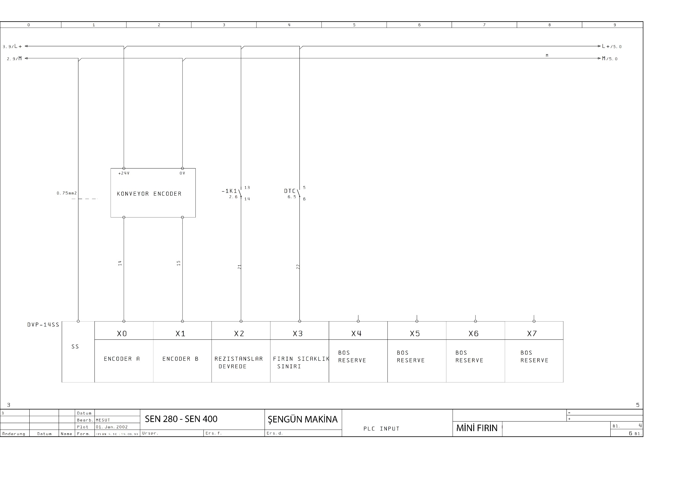

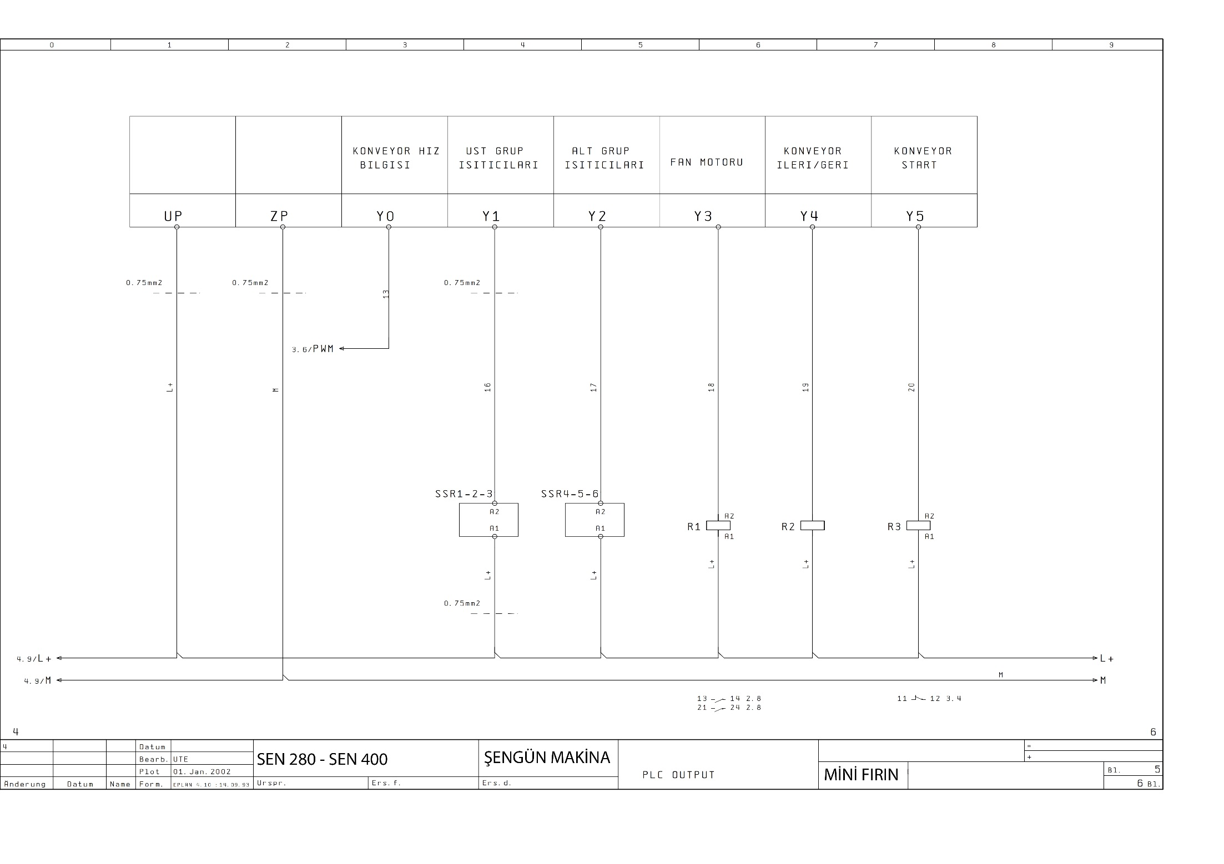

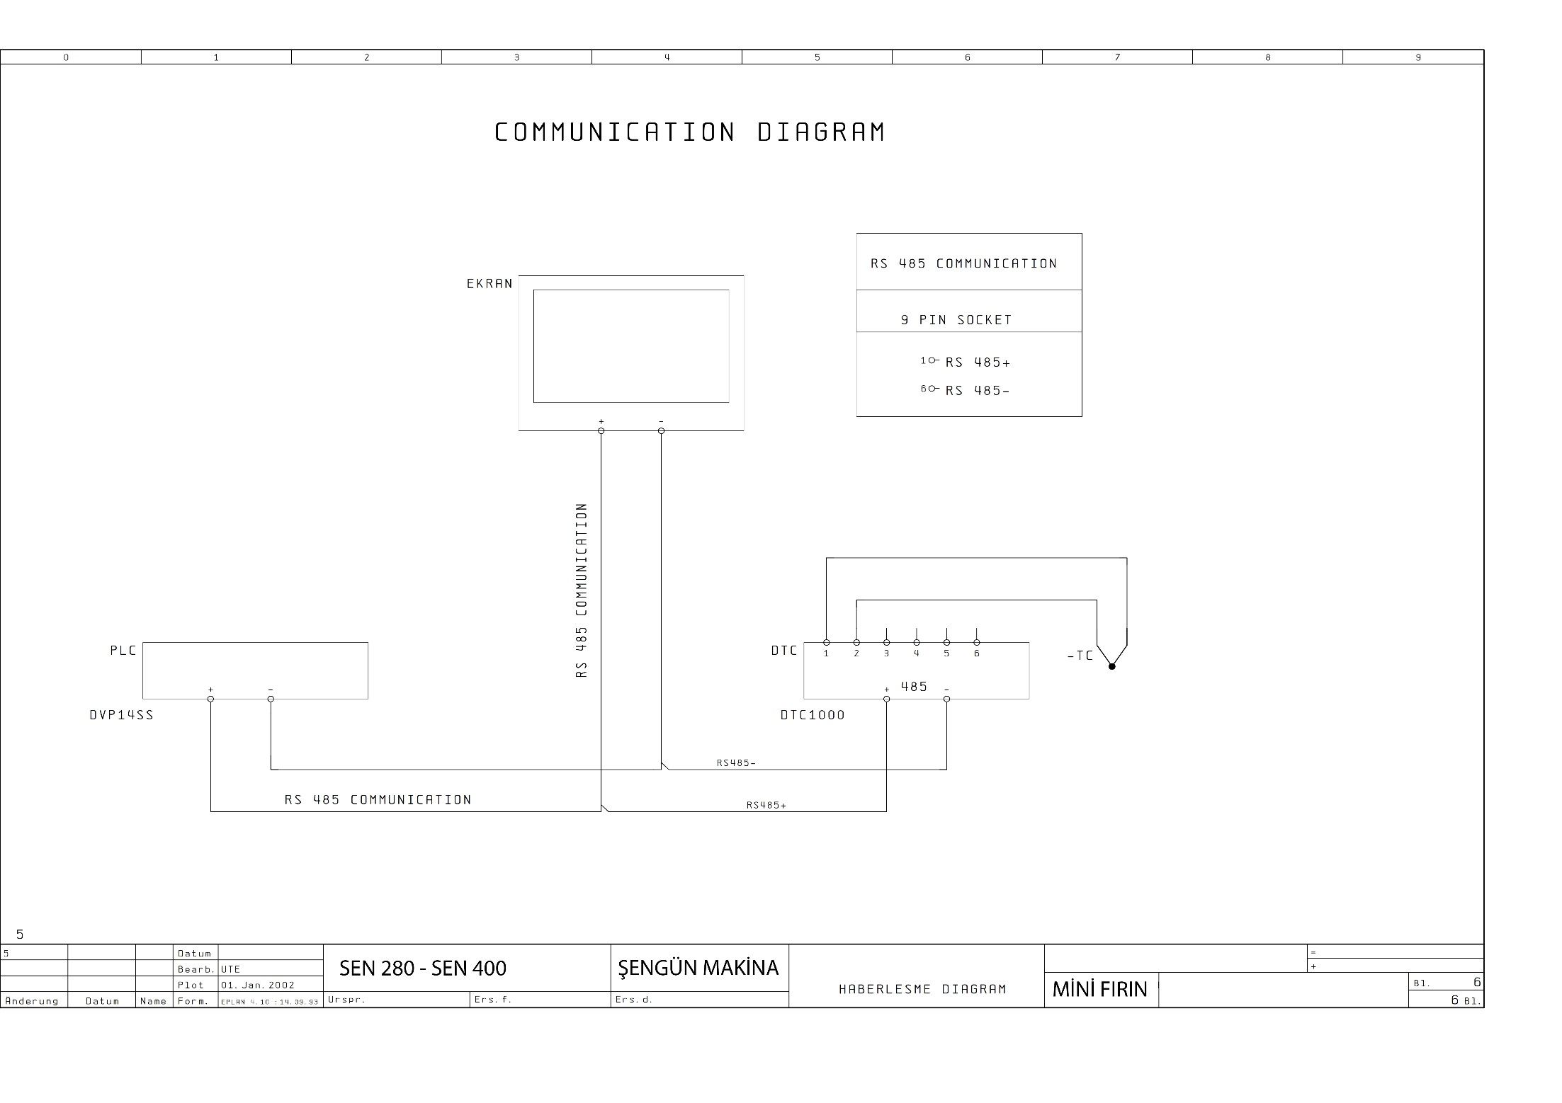

**SECTION 8: TROUBLESHOOTING**

**8.1 Temperature Limit Exceeded**

If the temperature value rise up over the upper heating zone 650 °C or If the temperature value rise up over the lower heating zone 550 °C “Temperature Limit Exceeded” message appears. Shut down the oven, wait until cooling of the oven. Then turn on the switches.

Temperature Limit Exceeded.

Reset the Oven

Check the Temperature in Cooking Page

High Temperature

0 Volt

Evaluate to entrance voltage of the SSR Valve Relay (3-4 numbered DC)

Check the Out Relay Voltage (1-2 numbered)

100-200 V C

12 Volt + / -

Check the Relay cables

0 V proper relay

200-230 V Change Relay

0 DC damaged card or cable

Search the grounding short circuit of the heaters.

İnfinite resistance

RX1 Resistance indicates the grounding.

Remove the caps and check the contact with the heater chassis

Heaters ungrounded

Heat transfer trouble

Replace the heater if there is no contact or damaged.

Check the above steps with a qualified electrician. If problem does not solve, contact with our service.

**8.2 Low Battery Warning:**

Turn off and on the Switch

If error message disappeared, the reason of error is low voltage or interruption.

There is no changing

Screen Works properly about one month, even this message appears.

You must change the battery of the screen in one month.

The changing battery without energy, cause the software losses.

***Not: Battery can be supplied by electronical markets, services and producer.***

**8.3 Belt Engine Failure:**

“Belt Engine Failure” message appears when a problem with the conveyor motor.

Turn switch off and on

Check the cooking time values.

If the conveyor speed value is bigger than four minutes, conveyor can pause some times. This is not a problem

Check the conveyor cylinders if the conveyor speed value is less than four minutes

Conveyor cylinders do not rotate

Conveyor cylinders rotate

Conveyor belt can be loosen. The belt needs to be adjusted. Contact with the service

Check the conveyor motor and motion capture pipe. If they work, check the speed control staff

If motor speed control device has a problem, check the conveyor belt against to foreign materials

If motor speed control device hasn’t a problem contact with the service

Remove the foreign materials. Turn switch off and on. Press the RUN button and start

If oven still doesn’t work contact with the service

**8.4 Temperature Determine Failure:**

If any temperature value couldn’t detected by control panel, “Temperature Determine Failure” message appears.

Check the thermocouple connections

Failure continues

Turn switch off and on

Temperature determine failure

Change the thermocouple

Change the card

If failure still continues, contact with the service

**8.5 Temperature Does Not Rise:**

If Oven temperature doesn’t rise for five minutes, “Temperature does not Rise” message appears.

İf failure continues, contact with the service

Check the relays

Check the contactor

Turn switch off and on

Temperature does not rise

**8.6 Products Do Not Cooked:**

Products don’t cook

Failure fixed

Check the cooking time and temperature settings. Conveyor belt can move too fast

High temperature switch could be activated

Check the burner

Press the red button where is above of the high temperature switch

Touch the stop button on screen. Turn switch off and on two or three times. Than press start

Engine sensor could be defective

If failure continues, contact with the technical service.

**8.7 Contact with Technical Services:**

If the oven fails to operate, check the circuit breaker to be sure it is turned on. In addition, be sure that the circuit breaker is good before you call the Authorized Service Agency. The name and phone number of the Authorized Service Agency should be located on the oven or contact the factory for the name of the nearest Authorized Service Agency.

**SECTION 9: LABELS**





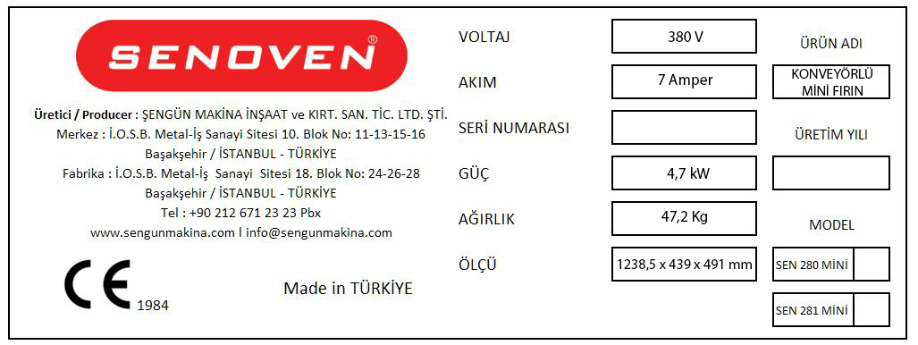

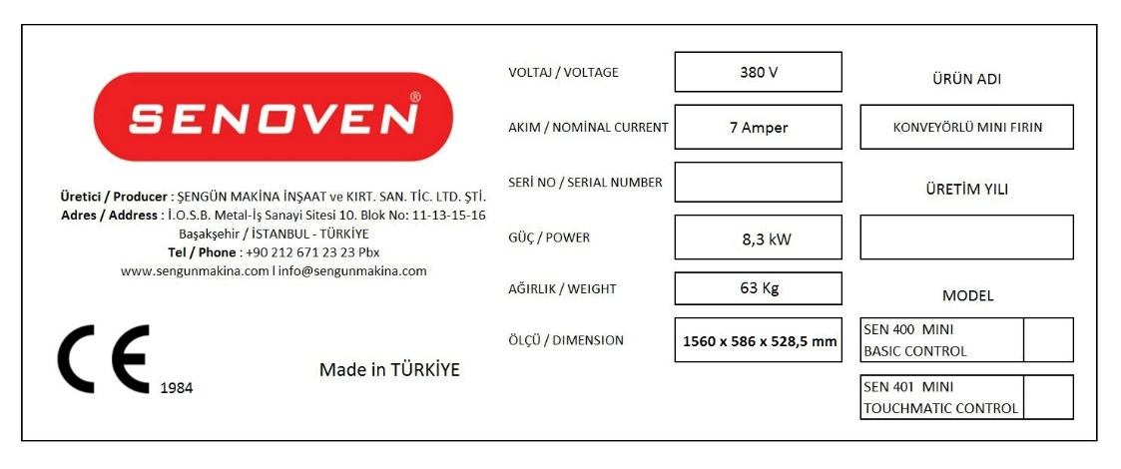

**Technical Label (Product Card)**



**High Temperature Hot Surface Warning**

**NOTE:**

|  |
| --- |
|  |
|  |
|  |
|  |
|  |
|  |
|  |
|  |
|  |
|  |
|  |
|  |
|  |
|  |
|  |
|  |
|  |
|  |
|  |
|  |
|  |
|  |
|  |
|  |
|  |
|  |
|  |
|  |
|  |
|  |
|  |
|  |
|  |
|  |
|  |
|  |
|  |
|  |
|  |
|  |
|  |
|  |
|  |
|  |
|  |
|  |
|  |
|  |
|  |
|  |
|  |
|  |



**ŞENGÜN MAKİNA İNŞAAT VE KIRTASİYE SAN. TİC. LTD. ŞTİ.**

İkitelli Organize Sanayi Bölgesi, Atatürk Bulvarı, Pufa İş Merkezi No: 98 Bodrum Kat: 2-3

Başakşehir/ İstanbul/ Türkiye

Phone: +90 212 671 23 23 (Pbx)

Phone 2: +90 212 671 84 84

Fax: +90 212 671 88 28

GSM: +90 533 957 14 53

**e-Mail :** [**info@sengunmakina.com**](mailto:info@sengunmakina.com)

**web :** [**www.sengunmakina.com**](http://www.sengunmakina.com)